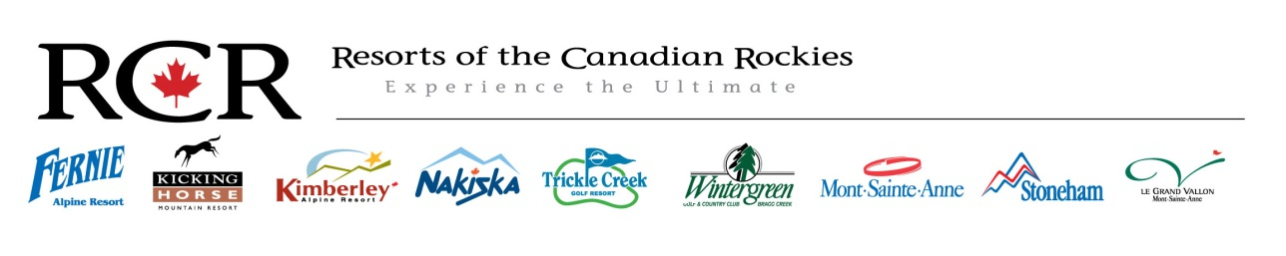
Nakiska Winter Sports School Daily Lead Winter 2015-16
Full Time Positions
Wage: $21.00 and up
Position Overview:
The position will be split between the Team lead role and Instructing depending on the day and school needs
As Lead
To provide the supervisor team required support for day to day operations including but not limited to organizing and delegating lessons. Updating and organizing booking system and multi week programs. Update the Sports School Facebook Page. Ensure other instructors are on task and on time for daily duties. Ensure the snow school standards are fallowed by staff members. Leads will need a basic understanding of all major snow school facets to be able to preform the role at a high standard. This includes sales, product knowledge etc.
As Instructor
To provide guests with a high quality of ski and/or snowboard instruction. Guests will be of all ages and ability levels and lesson types will vary. Help to ensure that every guest has a safe, fun & informative experience. Carry out duties and other tasks set out by the Winter Sports School as and when required.
Key Areas of Knowledge:
- Abide by policy and procedures as outlined in the Nakiska Resort Staff Handbook
- Abide by policy and procedures as outlined in the Winter Sports School Orientation Training
- Assisting guests with resort related queries
- Adhere to Nakiska Resort health and safety polices and incident /hazard reporting system
- A good knowledge of Canadian ski &/or snowboard instruction practices, (CSIA, CASI)
- A strong departmental knowledge

Key Responsibilities:
- Provide support to the school's supervisors to allow each team member the ability to focus on their individual or group goals.
- Delivery of excellent ski &/or snowboard instruction, in accordance with standards established by the Ski & Snowboard School.
- Be willing to accept all assignments that fit within your level of qualification and position in the Winter Sports School.
- Provide guidance and feedback in a manner that is supportive, encouraging and helps students/ instructors achieve their goals.
- Provide a superior level of guest service and mountain safety to all visitors and staff.
- Ensure all communication is professional with guest and staff, timely and supports the best interests of Nakiska Resort.
- Assist other mountain departments/Management with operational or services tasks assigned by your Supervisor/Manager
- Consistently present and maintain a neat, clean and tidy appearance and a professional image as outlined in your department manual.

Key Skills:
- Have a strong work ethic and work place standards
- Strong listing and communication skills
- Be flexible and adaptable so as to be able and willing to help in all snow school facets.
- Minimum level 2 internationally recognized qualification(s) in ski &/or snowboard instruction.
- The ability to interpret and apply ski &/or snowboard instructing concepts and terminology in to simple guest friendly terms.
- The ability to work without supervision in a methodical and responsible manner.
- Have a positive attitude and a team orientated work ethic.
- Be punctual, reliable and responsible.

The closing date for applications is November 1st 2015. Send your current resumé and a cover letter to mricher@skinakiska.com.

