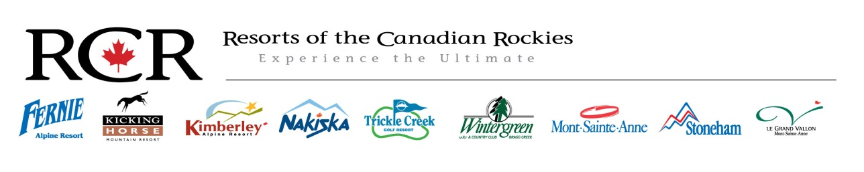
Nakiska Winter Sports School Sales Representative Winter 2015-16
Full Time
Wage: Starting at $15.00 and up
Position Overview:
The main goals are to book lessons, assist guests with resort related queries and provide the best possible guest experience and service. Furthermore is to ensure all ski and snowboard lesson bookings are efficient and accurate. This will include bookings taken face-to-face, over the phone and via email.
Key Areas of Knowledge:
- Abide by policy and procedures as outlined in the Nakiska Resort Staff Handbook
- Have knowledge of Winter Sports School product, ticketing operations and other resort facilities.
- Have/develop knowledge of skiing and snowboarding to strengthen ability to assess lesson levels to ensure accuracy of lesson bookings.
- Adhere to Nakiska Resort health and safety polices and incident /hazard reporting system

Key Responsibilities:
- Provide a superior level of guest service and mountain safety to all visitors and staff.
- Ensure all communication is professional, timely and supports the best interests of Nakiska Resort.
- Ensure all correspondence and information given is accurate and correct.
- Booking of lessons face-to-face, over the phone and via email.
- Money handling and cash out procedures.
- Duties will extend to tasks set out by supervising staff for the benefit of the Winter Sports School.

Key Skills:
- Excellent communication skills
- Previous experience or knowledge of skiing and/or snowboarding.
- Previous experience with money handling.
- Computer literacy is essential, programs include office, in-house booking systems and multiple POS systems.
- Have a team orientated work ethic.
- Strong work ethic with an ability to work under pressure in a fast paced environment.
- Strong organizational skills.
- A positive attitude.

The closing date for applications is November 1st 2015. Send your current resumé and a cover letter to mricher@skinakiska.com.

