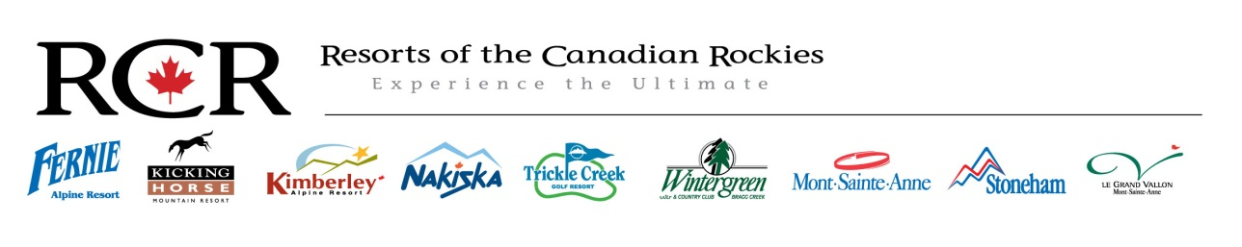
Nakiska Winter Sports School Ski/Snowboard or Dual Instructor Level 4 Winter 2015-16
Starting Wage: $24.00 per hour and up
Full Time or Part Time
Position Overview:
To provide guests with a high quality of ski and/or snowboard instruction. Guests will be of all ages and ability levels and lesson types will vary. Help to ensure that every guest has a safe, fun & informative experience. Carry out duties and other tasks set out by the Winter Sports School as and when required.
Key Areas of Knowledge:
- Abide by policy and procedures as outlined in the Nakiska Resort Staff Handbook
- Abide by policy and procedures as outlined in the Winter Sports School Orientation Training
- Assisting guests with resort related queries
- Adhere to Nakiska Resort health and safety polices and incident /hazard reporting system
- A good knowledge of Canadian ski &/or snowboard instruction practices, (CSIA, CASI)

Key Responsibilities:
- Delivery of excellent ski &/or snowboard instruction, in accordance with standards established by the Ski & Snowboard School.
- Be willing to accept all assignments that fit within your level of qualification and position in the Winter Sports School.
- Provide guidance and feedback in a manner that is supportive, encouraging and helps students achieve their goals.
- Provide a superior level of guest service and mountain safety to all visitors and staff.
- Ensure all communication is professional, timely and supports the best interests of Nakiska Resort.
- Assist other mountain departments/Management with operational or services tasks assigned by your Supervisor/Manager
- Consistently present and maintain a neat, clean and tidy appearance and a professional image as outlined in your department manual.

Key Skills:
- Minimum level 1 internationally recognized qualification(s) in ski &/or snowboard instruction.
- The ability to interpret and apply ski &/or snowboard instructing concepts and terminology in to simple guest friendly terms.
- The ability to work without supervision in a methodical and responsible manner.
- Have a positive attitude and a team orientated work ethic.
- Be punctual, reliable and responsible.

The closing date for applications is November 1st 2015. Send your current resumé and a cover letter to mricher@skinakiska.com.

