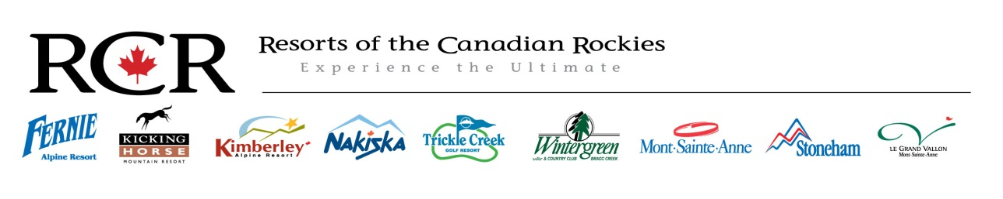
Nakiska Winter Sports School Supervisor 2015-16
Full Time
Wage: Starting at $22.50 per hour and up
Position Overview:
To oversee all aspects of the Winter Sports School related to instructors and an overall understanding of the guest service aspect and assist the senior school management with the operation of the snow school.
Key Areas of Knowledge:
- Abide by policy and procedures as outlined in the Nakiska Resort Staff Handbook
- Excellent knowledge of services and products offered by the snow school.
- Strong and broad knowledge of snow school operations.
- In-depth knowledge of resort services.
- Adhere to Nakiska Resort health and safety polices and incident /hazard reporting system
- A good knowledge of Canadian ski &/or snowboard instruction practices, (CSIA, CASI)

Key Responsibilities:
- Work with the Senior management to sustain and develop the quality of the snow school.
- Fulfill all duties delegated by the senior management.
- Ensure performance goals are set and met in a timely manner.
- Organize and provide training and guidance to all instructors.
- Organize and delegate duties to instructors and daily lead staff.
- Scheduling.
- Provide guidance and feedback to instructors in a manner that is supportive, encouraging and promotes achievement within their role.
- Provide a superior level of guest service and mountain safety to all visitors and staff.
- Consistently present and maintain a neat, clean and tidy appearance and a professional image as a role model to all staff.
Key Skills:
- Previous management experience preferred.
- Minimum level 2 internationally recognized qualification(s) in ski &/or snowboard instruction. Level 3 preferably
- I.T skills essential; experience with email accounts, office, computer based booking systems.
- Experience with money handling and cash out procedures preferred.
- Have a positive attitude and a team orientated work ethic.
- Be punctual, reliable and responsible.

The closing date for applications is November 1st 2015. Send your current resumé and a cover letter to mricher@skinakiska.com.

