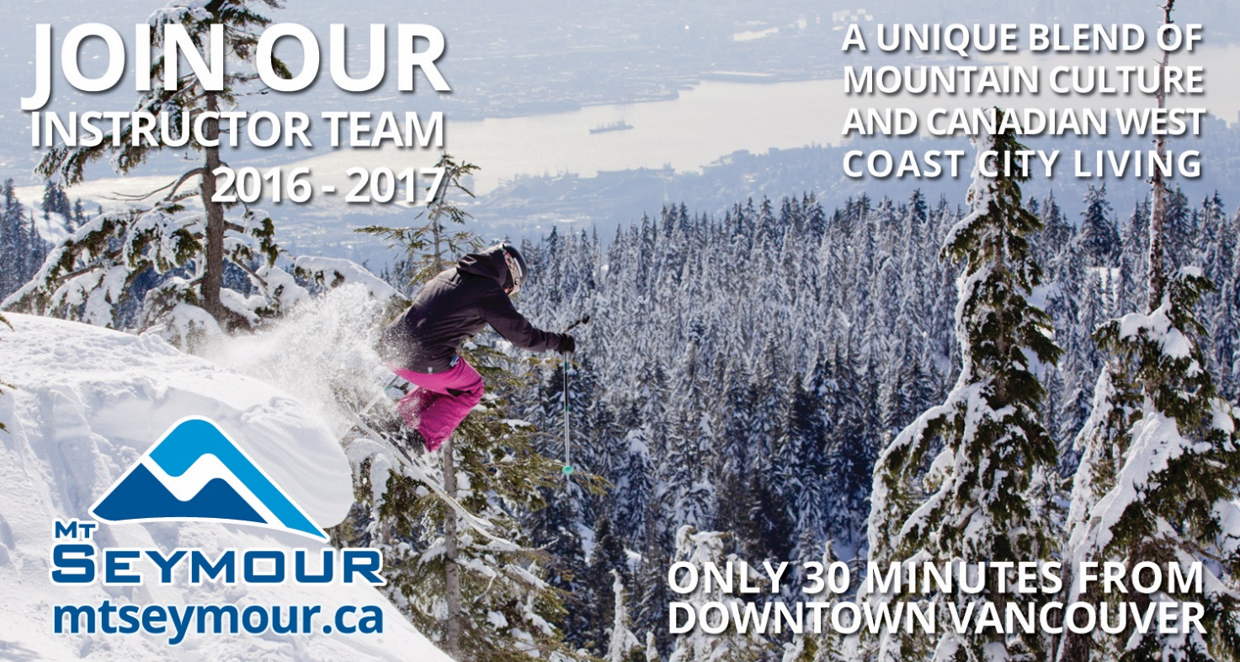
Mt Seymour is a winter recreation area located in North Vancouver, British Columbia, Canada. We are located about 30 minutes from the vibrant west coast city of Vancouver. Working for Mt Seymour as part of our Ski & Snowboard School offers the best mix of a resort lifestyle located close to a major metropolitan center.
Mt Seymour requires enthusiastic, friendly and highly motivated instructors to join our team for the 2016-2017 Winter Season and share their passion for skiing and riding with our guests.
We are known as Vancouver's place to learn to ski and ride. Our Ski and Snowboard School provides a fun and professional atmosphere in which to work with a culture of progression.
Mt Seymour hosts a great backcountry, world-class terrain parks, a state of the art covered Magic Carpet and a newly installed detachable quad lift.
We offer:
- Competitive wages starting at $13.25 per hour to $19.65 per hour depending on qualifications and experience.
- Travel allowances of up to $1000.00 for F/T, certified instructors travelling internationally to work for Mt Seymour ( must have valid work visas to qualify, some restrictions apply )
- We also provide instructor scholarships to help pay for course upgrades, and a reciprocal pass agreement program which offers discounted tickets and passes at other participating resorts in Western Canada and the US.
- Complimentary Seasons Pass and discounted shuttle bus pass.
- Resort & Equipment Discounts
- Mt Seymour does not offer staff accommodation; however, North Vancouver offers a variety of housing options and we are happy to help facilitate the process of sharing housing with fellow instructors.
These are seasonal full-time positions (20-40 hours per week), with extra work during peak operating periods. Season is December to Mid-April, with Orientation training in early December.
Instructors are responsible for providing a great learning experience to our guests, a large proportion of whom are children.
If you are a certified (CSIA/CASI or equivalent foreign certified )Ski or Snowboard Instructor with your own working visa for Canada please contact us for more information or apply by submitting your resume / cv and a letter telling us about yourself to hr@mtseymour.ca or visit our website at www.mtseymour.ca.
We would also be interested in hearing from anyone interested in becoming a Ski Instructor with our resort, to be considered you must be a strong skier with experience working with children or teaching sports. We will have some spots available for people to take the CSIA level 1 Ski Instructor program at the start of the season and then join our Ski & Snowboard School to work as an instructor for the balance of the 2016-2017 season. Please contact us for more details.

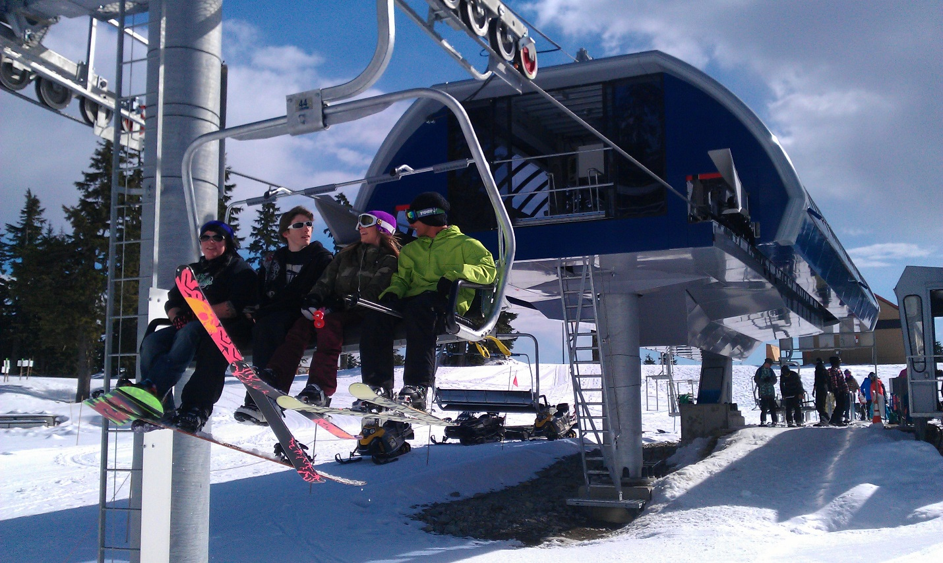

https://www.facebook.com/MtSeymour

