METHVEN / MT HUTT ACCOMMODATION.

Boulder Bay Cottage.

Special discount offered to current NZSIA members.

Only $35 / night with sleeping bag or $40 without.

The owner is a life time member of NZSIA and has hosted exam candidates for many years.
Centrally located, opposite the I Site centre , Memorial Hall and meters from all the local bars, restaurants and retail outlets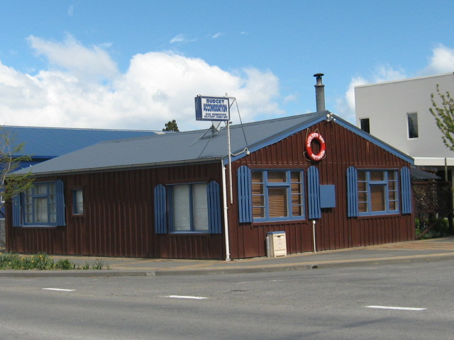.
Check out Book a bach ID 1862 for more pics but book through me for your NZSIA special discount.
Jan Lane
janlane@xtra.co.nz
Ph 0274 621 701
03 3028608

