skiing and
external forces
滑行与外力作用

Ski instructors should not underestimate the importance of understanding the principles that make a ski speed up, slow down, or change direction. This chapter defines some of these basic concepts and looks at how they are applied. It explains the forces acting on a skier when standing still, then in a straight run, to demonstrate the basic forces that set skiers into motion, speeds them up and slows them down. Finally it studies the changes in these forces when a skier turns.
滑雪教练员不应忽视对雪板运动原理的了解，包括雪板加速、减速、转向的运动原理。本章阐述了相关的一些基本概念和应用。本章内容还包括静立和直滑降中力作用于滑雪者的情形，并解释了让滑雪者移动、加速和减速的力的情况。最后分析了转弯时力的变化。

3.1 force
3.1 作用力
The term force describes something that causes a skier to undergo a change in speed or direction. It is simply anything that pushes or pulls on an object. This chapter discusses the interaction between the combination of skier and skis and the snow surface.
作用力是导致滑行速度和方向改变的力，简而言之，就是对一个物体施加推或者拉的力。本章主要讨论滑雪者和雪板与雪面的互动关系。
Two categories of forces are experienced when skiing:
在滑行时可以体验到两种作用力：
internal forces
内部作用力
Forces generated by the skier through muscular-skeletal movements. These types of forces are covered in the Chapter 2 Skiing–A Sport of Movement pg. 38
内部作用力由身体的肌肉骨骼运动产生，我们已经在第2章《滑雪中的身体运动》第38页进行了阐述。
external forces
外部作用力
Gravity, friction and the reaction forces from the snow. These are forces that act upon a skier. A skier must manage these forces through proactive and reactive movements to stay in balance.
外部作用力来自于重力、摩擦阻力和雪的反作用力。这些力从外部作用于滑雪者。滑雪者需要通过主动（前摄的）和反应性的运动来管理这些作用力以维持平衡。
3.1.1 managing the forces
3.1.1 作用力的管理

A skier and the equipment they are wearing (boots, clothing, etc) is a skier’s mass. This term is defined as a measurement of the quantity of matter an object possesses. This is slightly different than the term weight, which is a measurement of gravity’s effect on the object. An object with greater mass will have a larger weight because gravity is a constant.
滑雪者和其穿着的装备（雪靴、雪服等）被一道视作滑行者质量，质量是一个物理学名词，指一个物体所拥有的物质的量。质量与重量的含义略有不同，重量是物体受重力影响的值。但因为重力是恒定的，因此拥有较大质量的物体也会有较大的重量。

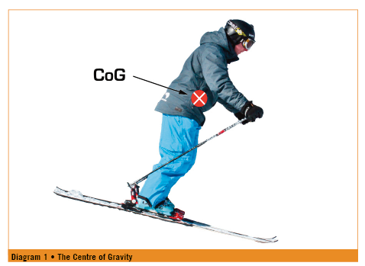

The skier’s centre of gravity is defined as the mean location of the weight of a body. For our purposes it is the theoretical point in the body where all mass acts as if it is concentrated. As a skier moves, this point may be inside of or outside of the body (see diagram 1). Where this point is located determines where the skier is balanced on the skis. When we describe the location of the skier’s centre of gravity we describe its relationship to the base of support. This is defined as the portion of the ski or skis under the foot or feet. A skier standing still on flat ground is in balance when their centre of gravity is centred over their base of support from a lateral and fore/aft perspective.
滑雪者的重心，指的是身体重量的中心位置。对双板滑雪而言，它是质量集中于此的一个假想点。滑雪者运动时，重心可以在身体之内，也可以在身体之外（见图1）。重心点的位置决定了滑雪者在雪板上的平衡点。我们谈到滑雪者的重心时，通常是为了描述它与支撑面的关系。支撑面是指脚部与雪板的接触面。当滑雪者在水平地面上静立，只有在身体重心处于支撑面上方正中时，滑雪者才处于身体平衡的状态。
A skier standing still on two flat skis, with their centre of gravity balanced over the middle of their base of support will be evenly balanced over two feet. The result of this is felt as pressure against the soles of both feet. Pressure is represented by the equation P=F/a where P = Pressure, F = Force, and
a = area (units are N/m2). It is important to understand that if the contact area is reduced or the force is increased the pressure is increased. For example, when a skier lifts their right ski off the snow they reduce the surface area (a), but force (F) - the skier’s weight - remains unchanged, therefore pressure (P) has increased on the left ski.
滑雪者站立于两支水平放置的滑雪板时，他们的重心位于两脚支撑面之间的正上方，体重则平均分配给双脚。体重对支撑面的压强公式为P=F/a，P=压强，F=压力，a=受力面（单位：N/m2），当受力面面积减小或压力增大，压强也会相应增加。当滑雪者抬起右雪板，则受力面（a）减小，压力（F）即滑雪者体重并未变化，因此左雪板所受的压强增大。

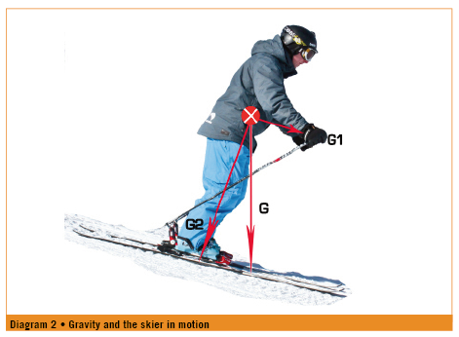

The relationship of these two reference points will become increasingly important as the skier moves from the static example above, to being in motion.
滑雪者从静立状态进入运动状态后，重心与支撑面的关系变得更加重要。
In general the force that puts a skier in motion is gravity. A skier in a straight run is pointed down a shallow slope and therefore begins to move. Since gravity (G) always pulls us towards the centre of the earth, we will break the effects of gravity into a few components to show how it puts the skier into motion (see diagram 2).
滑行的动能来自重力。直滑降时，滑行者面向山下，地形坡度带来运动的势能。由于重力（G）是地球对我们的吸引力，因此力的方向指向地心，我们把重力对滑行者的势能影响分成几个部分解释（见图2）。
G1 is the component of gravity that puts the skier into motion. G1 is parallel to the slope. G2 keeps the skier in contact with the terrain. G2 is perpendicular to the slope.
As skiers straight run down a gentle slope they begin to speed up. This is an example of acceleration. Acceleration is defined as a change in velocity, or speed in a particular direction, of an object. Acceleration happens when there is an external force applied to an object. In the case of the skier in a straight run gravity causes the skier to accelerate. Further examples of acceleration are changing direction, speeding up as skis are pointed down a slope, slowing down through skidding or braking.
G1是使滑行者运动的重力势能，它与坡面平行。G2则使滑行者始终与地面贴合，力的方向与坡面垂直。
当滑行者在一个缓坡做直滑降时，速度不断加快，即是产生了加速度。加速度用以描述速率的变化，在这儿指物体朝特定方向运动的速度不断加快。加速度的产生是由于外力施加于物体之上，在此是指作用于滑行者的重力，即重力加速度。其他与加速度有关的情形包括改变滑行方向、板头朝向坡下时速度的加快，以及通过搓雪和刹车进行减速。
If two skiers of different sizes are both straight running on the same gentle slope, with a natural run out, the smaller skier will begin to slow down and stop in a shorter distance than the larger skier. This is because the larger skier, the one with greater mass, has more momentum. Momentum is defined as “quantity of motion.”
It is the product of the body’s mass and velocity or speed. The greater momentum the more a body will resist change in motion.
如果在同一缓坡，不同体重的两名滑雪者同时进行直滑降并自然减速停止，因为质量（体重）大的物体动量也较大，所以体重轻的减速更早，滑行距离也会更短。动量是物体“运动的量”，与物体质量与速度/速率相关。在滑雪运动中，人体的动量越大，运动状态就越不容易改变。（动量也是物体在它运动方向上保持运动的趋势，从外在表现上看类似惯性，但惯性是质量概念，不受速度影响，动量是一个物理矢量，两者有本质区别。——译者注）
The force that resists the motion of sliding on or through a surface is defined as friction. Simply put it is friction which slows a skier down.
在物体表面滑行或穿过某表面时所遇到的阻力称为摩擦阻力，摩擦阻力使滑行速度减缓。
A skier experiences two types of friction:
• friction from the surface of the snow
• friction from the air - also called wind resistance
滑行的摩擦阻力有两种：
• 雪面摩擦阻力
• 空气阻力，也即风阻
The direction of friction is generally the opposite of the skier’s momentum. In a straight run the force of friction is parallel to the skis; in a hockey stop it is perpendicular to the skis (see diagram 3).
摩擦力与滑行者的动量通常方向相反。直滑降的摩擦阻力方向与雪板平行，在横板急停（hockey stop）时，摩擦阻力与雪板垂直（见图3）。
When skiers wax their skis they are attempting to lower the amount of friction acting upon the skis to allow them to travel faster. A ski racer wearing a speed suit is doing so to lessen the slowing effect of wind resistance. A freestyle aerialist, on the other hand, often wears looser fitting clothing in order to use wind resistance to control or alter their rotation in the air.
我们给雪板打蜡的目的，也是为了减少雪板受到的摩擦阻力、加大滑行速度。竞速滑手穿着速滑服则是为了降低风阻。相反，自由式空中技巧/公园滑手则通常穿着宽松，方便利用风阻控制和调整在空中的旋转。
When skiers attempt a spin or 360 they are creating rotational momentum. This is defined as a quantity of rotation of a body. Once they begin to spin they will continue to spin until an outside force, such as friction, acts on them. Similarly they will continue to spin in the same direction until an outside force acts on them to change direction. When performing a 360 in the air a skier gains rotational momentum through takeoff and continues to spin in the same direction until landing. While rate can be affected, the direction of rotation will remain constant. As in the example of a straight run, given everything else is equal, a larger skier will spin for longer than a smaller skier.
当进行旋转或360时，会产生旋转动量，即身体的旋转量。旋转一旦开始就会一直持续，除非受到外力作用，比如摩擦阻力的影响。同样，旋转也会始终保持一个旋转方向，除非受到外力作用而改变。在空中进行360转体时，人体在起跳时获得了旋转动量，在空中以同样的方向继续旋转直至落地。旋转速度可能发生变化，但是方向不变。与直滑降相似，在其他条件相同的情况下，体重大的滑行者将会比体重轻的旋转得更久。
In a ski turn we move both linearly (momentum) and about an axis (rotational momentum). Any change in the velocity of a body in motion, speeding up, slowing down or change of direction is due to the application of an outside force. That outside force can come from friction, wind resistance or deflection from terrain or another body.
在滑行转弯时，既有线性运动（动量），也围绕一个中心轴旋转（旋转动量）。人体运动的任何速率变化、加速、减速或转向都是由于外力的作用，这个外力可以来自摩擦阻力、风阻力、地形的偏斜或者他人。

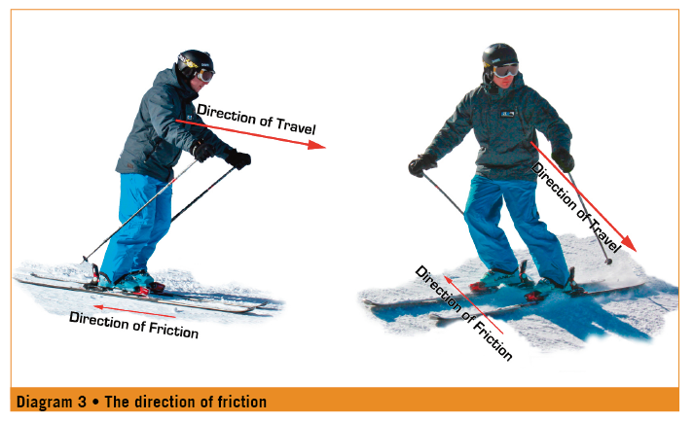

3.2 forces acting upon the skier in a turn
3.2 转弯时作用于人体的力

Sir Isaac Newton identified a set of laws that involve forces and acceleration, momentum and inertia.
牛顿有一系列定律，对作用力和加速度、动量和惯性做出了解释。
• The first law states that an object in a state of motion tends to stay in that state of motion unless an external force acts upon it. This is the definition of inertia. In a straight run a skier will continue to go straight unless an external force causes the skier to turn. A skier will not change direction unless a force acts upon them. This means that the skis need to interact with the snow so that the snow can push the skier around the turn.
• 牛顿第一定律：任何物体都会保持匀速运动或静止的状态，直到外力作用导致物体运动状态的改变。这也是惯性的定义。在直滑降时，滑行者会持续直线运动，除非受到外力作用发生转弯。只有受力才能改变滑行方向，意味着雪板需要与雪面发生互动关系才可能发生转弯。
• The second law defines the relationship between mass, force and acceleration. This is represented by F=ma. This states that the direction of the force is the same as the direction of the acceleration. An example is a skier in a wedge turn engages the inside edge of the left ski which causes the snow to push against the left ski. The direction of this external force is to the right causing the skier to veer to the right.
• 牛顿第二定律主要描述质量、作用力和加速度的关系，公式为F=ma。定律表明加速度的方向与作用力的方向相同。例如，在犁式转弯中如果使用了左侧雪板的内刃，使雪推向左侧雪板，则此时的外部作用力指向右方，从而使滑行者向右转弯。
• The third law states that every action has an equal and opposite reaction i.e. that all forces involve two objects and the force acts with equal strengths but in opposite direction on both. In a ski turn the two objects are the skier (and skis) and the snow. The force from the snow pushes on the ski causing the skier to change direction. The skier responds with muscular tension to resist and balance against that force.
• 牛顿第三定律表明，相互作用的两个物体之间的作用力和反作用力总是大小相等、方向相反。在滑行转弯时，这两个物体分别是滑行者（及雪板）和雪。雪推向雪板的力导致滑雪者改变滑行方向，滑雪者通过肌肉紧张产生反作用力以达到平衡。

“Without G1 the skier would not be in motion” is an example of Newton’s first law.
“没有G1，滑行者就无法运动" 是牛顿第一定律。
“The skier accelerates in the direction of G1” is an example of Newton’s second law.
“滑行者以G1的方向产生加速度”是牛顿第二定律。
“The snow pushes back at the skier with an equal amount and in an opposite direction of G2” is an example of Newton’s third law.
“雪对滑行者产生的反作用力与G2方向相反、大小相等。”是牛顿第三定律。
Note that the steeper the slope the larger G1 will become, therefore the skier will accelerate more rapidly.
注意坡度越大，G1就越大，因此人体滑行的速度增加得越快。
As a ski is tipped up on edge it penetrates the snow and the snow presses back on the ski causing it to bend. The force from the snow pushing on the ski causes the skier to change direction. If we imagine a turn as a portion of a circle, the force acting on the skis is directed towards the centre point of the turn or the axis of rotation. This is called centripetal force and is responsible and essential for turning (see diagram 4).
雪板立刃切雪时，雪产生反作用力导致雪板发生弯曲形变，从而改变滑行方向。如果将转弯想象成圆的一部分，施予雪板的力指向弯的中心也即雪板旋转的中心轴，这个力称为向心力，它直接导致了转弯的发生，是转弯的必要条件（见图4）。
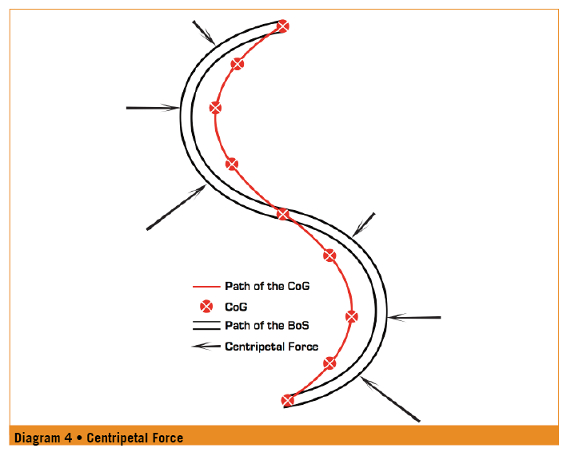

Any change in speed or size of the turn will change the amount of centripetal force. For example two ways to increase the centripetal force acting on the skier would be to either go faster or tighten the radius of the turn.
转弯速度和弯的大小决定了向心力的大小。增加向心力有两个方式，加快转弯速度或者缩小转弯半径。
Through the course of the turn the skier experiences the feeling of being pulled to the outside of the turn. This sensation is called centrifugal force. This feeling of being pulled to the outside can be described as the equal and opposite to the force from the snow that is causing the skier to turn, centripetal force (see diagram 5).
在转弯过程中，人体会感觉被拉向弯外，这种感觉被称为离心力，它可以被视作向心力的反作用力，与向心力方向相反、大小相等（见图5）。

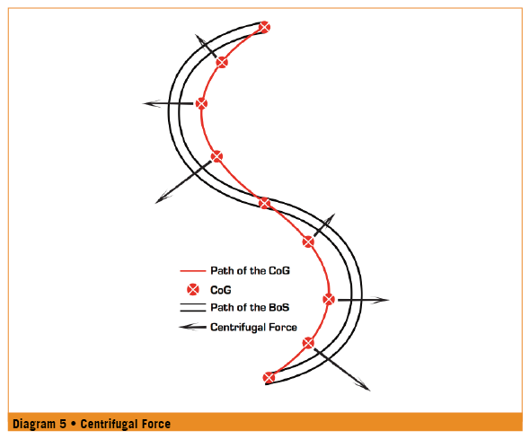

Centrifugal force is only experienced by the skier and is not observed from outside of that frame of reference. If the ski was to disengage from the snow the skier would not be thrown towards the outside of the turn, as the direction of centrifugal force would imply, but rather travel in a straight line on a tangent to the arc of the turn. This is the direction of the skier’s inertia at the point that the edges disengaged. This effect can be very helpful in communicating what a skier should feel through the course of a turn.
但离心力只是滑行者自己的一种感觉，无法被实际观察，如果此时雪板脱离雪面，滑行者并不会因为离心力被甩出弯外，而只会沿转弯弧线的切线依惯性做直线运动，弯道弧线与雪板脱离雪面的点形成的切线即是惯性的方向。这一现象有助于解释转弯过程中发生的人体感知。

3.3
the path of the centre of gravity in relation to the base of support
3.3重心与支撑面的路径关系

In all turns centripetal force is present. This force acting towards the centre of the turn means skiers must move their centre of gravity inside the path of their base of support to stay in balance.
所有转弯都有向心力的存在，由于向心力指向弯的中心，因此人体的重心也应该位于支撑面行进路线的内侧以保持身体平衡。
Therefore to balance against the force from the snow in a ski turn the centre of gravity must move inside the turn, which means when turning, the path of the centre of gravity will always be inside the path of the base of support (see diagram 6).
因此，为了平衡雪对雪板的推力，转弯时应将重心移动到弯内，重心的移动路线因此也保持在支撑面路线的内侧（见图6）。

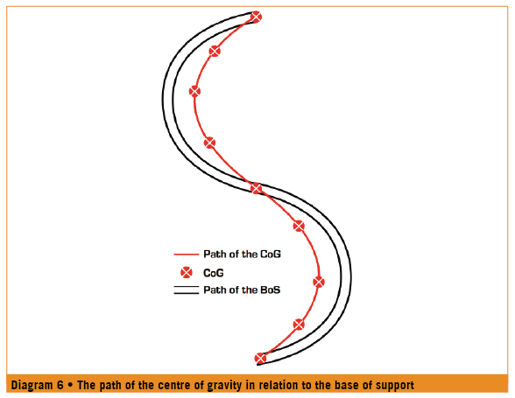
Lateral movement of the centre of gravity towards the centre of the turn is called inclination. As the skier inclines towards the centre of the turn, the path of the centre of gravity and base of support diverge. Some inclination is present in all turns.
重心向弯道内侧转移的横向运动称为内倾。随着人体向弯的中心倾斜，重心的运动路径就与支撑面的运动路径发生分离。所有转弯都有不同程度的内斜。
The degree skiers can incline, or move their centre of gravity inside their base of support is defined by the amount of centripetal force acting on them. The faster the skier goes or the tighter the radius, the greater the centripetal force (see section on centripetal force), and therefore the more a skier can incline. In a wedge turn the skier is travelling at a fairly slow speed and centripetal force, while present, is low in intensity. Therefore the path of the centre of gravity is close to the path of the base of support. A basic parallel turn is faster and the centripetal force is greater therefore the path of the centre of gravity and base of support are further apart. Finally, in a dynamic medium radius turn, the force from the snow is more intense. This requires the skier to incline a great deal to stay in balance, resulting in the centre of gravity and base of support following quite different paths (see diagram 7).
转弯的向心力决定了滑行者能够内倾的程度和重心偏离支撑面的程度。转弯速度越快或者转弯半径越小，向心力越大（参见向心力相关内容），人体能内倾的程度越大。在犁式转弯中，由于转弯速度相对较小，向心力强度也较小，重心的运动路线也相对接近支撑面的运动路线。相对的，基础平行转弯速度更快，因此向心力更大，重心与支撑面的运动路线就偏离得更大。而在一个动态的中等大小的转弯中，来自于雪面的力量也更大，人体需要倾斜相当大的角度来保持身体平衡，这也意味着重心和支撑面的运动路径有了显著的偏离（见图7）。
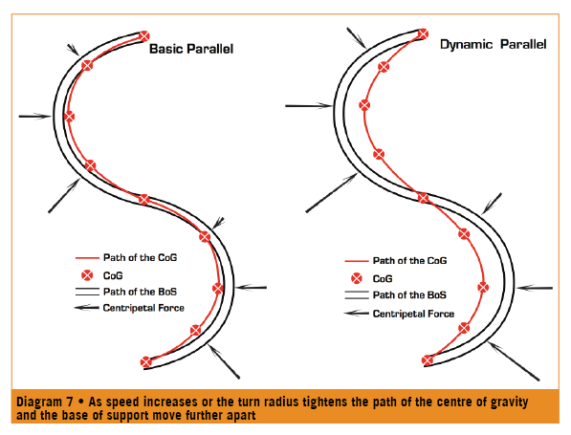

For turning to take place the ski must grip the snow to some degree. This is dependent on:
• the ski must penetrate the snow
• the snow must hold and push back against the ski
雪板的转向必须依靠一定程度的抓雪，抓雪需要：
• 雪板切入雪中
• 雪能卡住雪板并对其产生推力

On hard pack the snow compacts very little and reacts and pushes back very quickly. In powder and softer snow the reaction that creates turning, happens slower because the snow must compact to a point where it can push back against the ski, and cause the skier to turn.
在紧实的硬雪面（hard pack）上，由于较难推压，雪面反推的反应非常快，而在粉雪或者较松软的雪面上，由于雪面需要被压实到一定程度才能产生反推力，因此转弯需要的雪面反应要来得慢一些。
In a turn a skier experiences the combined effects of gravity and centrifugal force. This can be called the resultant force (ref. Ron LeMaster, Ultimate Skiing, 2009). This is the average of centrifugal and centripetal forces. The faster the skier travels through a turn the greater the centripetal and centrifugal forces. This results in the angle of the resultant force also being more inclined and allows for the skier to incline further. This is important to understand, because to what degree the ski grips is determined by the angle of the ski to this force.
在转弯过程中，人体能感觉到重力和离心力的综合影响，我们也可以称之为合力（参见《Ultimate Skiing》Ron LeMaster著，2009）。合力是离心力和向心力的平均值。滑行者转弯速度越快，向心力和离心力越大，而合力的角度也更倾向弯内，使得滑行者可以内倾更多。因此我们说，雪板和合力之间的角度决定了雪板的抓雪程度。
The reaction force from the snow is always perpendicular to the ski. When the ski is tipped up and penetrates the snow it creates a groove in the snow to support the ski. Assuming that the snow can hold the force of the ski and the ski, or platform is 90 degrees or greater to the resultant force, the ski will hold and carve. At angles greater than 90 degrees to the resultant force the ski will carve a tighter radius. If the ski is tipped to less than 90 degrees to the resultant force the ski will begin to slip and skidding will occur. The more the platform angle decreases the more the ski will skid. Controlling the relationship of the angle of the platform (skis) to the resultant force is controlling the amount of skidding a skier will use in a turn.
雪面的反作用力通常与雪板垂直。当雪板立刃切雪，在雪面上刻出凹槽形成雪板的支撑。假设雪面可以承托雪板的力量，而雪板（或者支撑平台）与合力形成大于等于90度的角，雪板就可以抓地卡宾滑行。如果这个角度大于90度，卡宾/刻滑转弯的半径就会变小，如果角度小于90度，雪板就会开始搓雪和推雪，角度越小，搓雪越多。控制支撑平台（雪板）和合力之间的角度，就是控制转弯时的搓雪程度。
3.4
pressure and pressure management – the sum OF IT ALL
3.4 压力和压力管理——总结

When a beginner skier balances the upper body towards the outside foot, or a more advanced skier accelerates down a blue slope making medium radius turns, the force increases. In both instances the skier experiences this increase in force as an increase in pressure.
当初学者将上身倾向外侧足，或者高阶滑雪者在蓝道上进行中型转弯速降，两者都会以感到压力增大的形式感受到力的增强。
At a fundamental level learning to ski is learning to harness and manage the forces acting upon the skier and the pressure those forces create. As skiers develop skills and ability they develop a desire to go faster and to steeper terrain. This will result in the skier experiencing greater forces acting upon them in the form of greater pressure. Skiers create and manage these forces through co-ordinating skilful movements of the body. The more ski instructors understand about the forces that are at work when skiing, the more able they will be to choose movement areas that will create successful outcomes.
在最本质的层面上，学习滑雪就是学会使用和管理力和力带来的压强。随着技术能力的提高，滑雪者渐渐希望能滑得更快，去到更陡峭的地形。两种情况都会以更大压强的形式让人体体会到更大的作用力。滑雪者通过有技巧地协调身体运动，产生和管理作用力。教练员对滑雪时力的作用情况了解得越多，就越能够选择恰当的身体运动达到预期效果。

Recommended reading for further studies
深入了解推荐阅读：
• Ultimate Skiing – Ron LeMaster, 2009 Human Kinetics
• 《极限滑雪》– Ron LeMaster, 2009 Human Kinetics
• Skiing Mechanics – John Howe, 1983 Poudre Press
• 《滑雪中的力学》– John Howe, 1983 Poudre Pres
• The Physics of Skiing; Skiing at the Triple Point – David A. Lind
and Scott P. Sanders, 2004 Springer

NOTES
附注

PICTURE CAPTIONS:
图片内容:

Diagram 1 • The Centre of Gravity
Diagram 2 • Gravity and the skier in motion
Diagram 3 • The direction of friction
Diagram 4 • Centripetal Force
Diagram 5 • Centrifugal Force
Diagram 6 • The path of the centre of gravity in relation to the base of support
Diagram 7 • As speed increases or the turn radius tightens the path of the centre of gravity
and the base of support move further apart
图1 • 重心
图2 • 重力与运动中的滑雪者
图3 • 摩擦力的方向
图4 • 向心力
图5 • 离心力
图6 • 重心相对于支撑面的运动路径
图7 • 如果速度增加或转弯半径缩短，重心和支撑面的运动路径进一步分离

