the biomechanics
of skiing
滑雪中的生物力学
This chapter provides background information on the biomechanics most relevant to skiing. It outlines how the muscles and skeleton function as a system to create balanced movement.
本章将会阐述与滑雪有关的生物力学相关信息，以及介绍肌肉骨骼系统如何形成运动平衡。
Bio Mechanics is the science of human bodies in motion. It combines the fields of mechanics (the physics of forces on objects in motion) and anatomy (muscles, bones and joints).
生物力学是人体运动的科学。它结合了力学领域（物体运动的物理力学）和解剖学（肌肉、骨骼和关节）。
Skiing efficiently requires balanced movement which is a blend of skeletal strength and muscular strength.
有效滑行所要求的运动平衡是骨骼强度和肌肉力量的共同结果。
Skeletal strength is when skiers are in an athletic stance and their body is balanced. The muscles have a functional amount of tension and the skier is supported primarily by skeletal strength. Bones stack on top of bones and there is minimal muscular action required to remain upright. If the skier moves away from the athletic stance muscles in the legs, abdomen, torso and neck must tighten/engage to keep an upright position. The skier is no longer relying on skeletal strength. The most efficient athletic stance involves a blend of skeletal and muscular strength that promotes the ability to move in any direction.
当滑行者处于滑行基础站姿并保持平衡时，肌肉会有一定张力，但主要的支撑来自于骨骼强度，骨骼各居其位，保持身体直立的肌肉运动非常少。一旦变换其他姿势，腿部、腹部、躯干和颈部的肌肉就需要参与活动/紧张，以保持身体的直立，这时，仅靠骨骼强度是不够的。最有效的滑行姿势是肌肉力量和骨骼强度的综合产物，朝任一方向运动都能游刃有余。

proprioception
本体感觉
This is kinesthetic awareness, involving the awareness of movement and the orientation in space of the body and its various parts, through internal sensors called proprioceptors. Located primarily in the joints, muscles, tendons, and the inner ear, proprioceptors are responsible for the kinesthetic awareness of what our bodies are doing. Developing a skier’s kinesthetic awareness is key to developing their ability to move accurately.
这是一种动觉意识，是通过一种叫做本体感受器的体内传感器，获得运动感知、身体及其各部分的空间定位意识。本体感应器主要分布于关节、肌肉、肌腱和内耳中，它负责感知我们身体的运动。滑行者建立动觉意识对他们控制身体做出精准动作非常关键。
anatomical body planes
人体解剖平面
These describe movements of the body using planes or directions of movement. For the purpose of most biomechanical descriptions, movement of the body is broken into three planes- sagittal, frontal and axial. The NZSIA uses four directions of movement to describe skiing. Fore/aft, rotational, lateral and vertical movement all exist within the three anatomical planes of motion as described below.
我们通过人体解剖平面和运动的方向描述身体运动。在生物力学描述中，人体运动通常被划分为矢状面、额状面和轴面。NZSIA使用四个方向的运动描述滑雪，即前后、旋转、横向和垂直运动，四个方向的运动都在下述的三个解剖平面的范围内活动。
The anatomical body planes dissect the body vertically and horizontally which intersect at the centre of gravity:
解剖平面将人体按照水平、垂直方向形成切面，在重心处交叉：
• Sagittal Plane – a vertical plane that runs through the body from front to back or back to front. This plane divides the body into right and left regions. NZSIA fore/aft and vertical movements occur within this plane
矢状面——从前往后或从后往前穿过身体的垂直切面，将人体区分为左半躯体和右半躯体。NZSIA的前后和垂直运动发生于这个平面中。
• Frontal Plane – a vertical plane that runs through the centre of the body from side to side. This plane divides the body into front and back regions. NZSIA lateral movement occurs within this plane
额状面——从一侧向另一侧穿过人体中心的垂直切面，将人体分为前半躯体和后半躯体。NZSIA的侧向运动发生于这个平面中。
• Axial or Rotational Plane – a horizontal plane that runs through the midsection of the body. This plane divides the body or parts of the body into upper and lower regions. NZSIA Rotational movement occurs within
this plane
轴面或旋转面（水平面）——贯穿人体中段部位的横切面，将人体分为上半部分和下半部分。NZSIA的旋转运动发生于这个平面中。
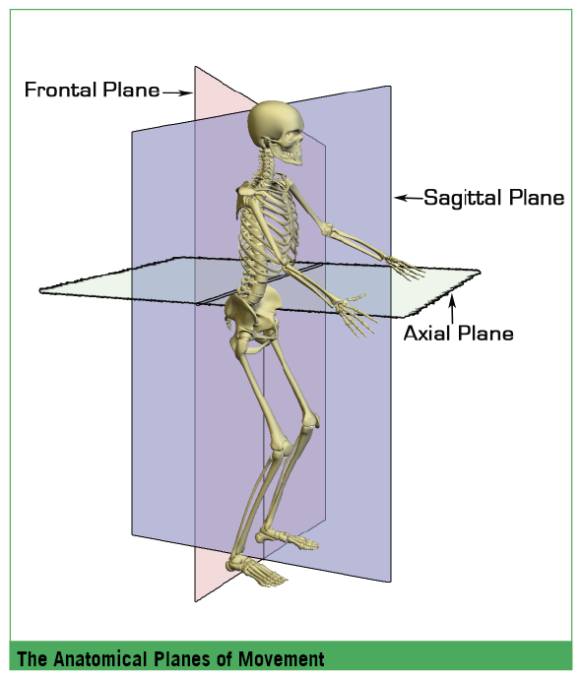

4.1 the human body
4.1 人体
The body can be broken down into its component parts:
Bones are the underlying rigid structures that form the skeleton. Bones are connected by joints to which muscles are attached.
人体由不同部分组成：
骨是构成骨骼的基础刚性结构，由关节连接，关节附着肌肉。

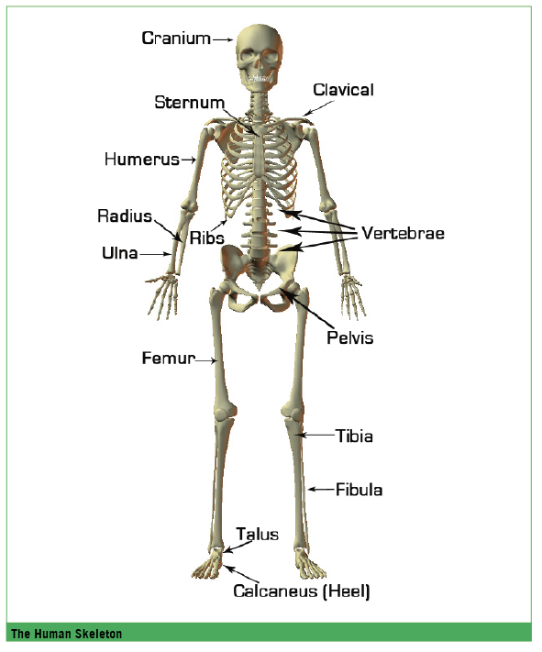
4.2 anatomy of the spine
4.2. 脊椎解剖结构
The spine is one of the more complex parts of the skeleton. The spinal column provides the main support for the body, giving it strength and enabling a person to stand upright. It is also flexible allowing the body to bend and twist in several planes while protecting the spinal cord from injury.
脊柱是骨骼系统中较为复杂的部分之一。脊柱为躯体提供了主要的支持和力量，使人能够直立。脊柱的灵活也使人可以在几个平面上进行弯曲和扭转，而同时脊髓受到椎骨的保护不致受伤。
The spinal or vertebral column extends from the skull to the pelvis and is made up of 33 individual bones termed vertebrae.
脊柱从颅骨延伸至骨盆，由33个独立的骨组成，称为脊椎骨或椎骨。
The vertebrae are numbered and divided into regions: seven cervical, twelve thoracic, five lumbar, five sacral and four coccygeal. Only the top 24 vertebrae are moveable; those of the sacrum and coccyx are fused. The vertebrae in each region have unique features that help them perform their main functions.
椎骨经过编号，被分为几个部分：7节颈椎、12节胸椎、5节腰椎、5节骶椎和4节尾椎。只有前24节椎骨是可以活动的；骶骨和尾骨部分是固定的。每个区域的椎骨都有不同作用和特点。
• Cervical region – the main function of the cervical spine is to support the weight of the head. The cervical region has the greatest range of motion
颈椎：主要功能是支撑头部的重量，颈椎的活动范围最大
• Thoracic region – the main function of the thoracic spine is to protect the organs of the chest by providing attachment for the rib cage. The range of motion in the thoracic spine is limited
胸椎：主要功能是缀接肋骨，保护胸腔器官，胸椎的活动范围有限
• Lumbar region – the main function of the lumbar spine is to bear the weight of the body. These vertebrae are much larger in size for their weight-bearing function. The lumbar region has the second largest range of motion
腰椎：主要功能是支撑身体的重量，由于负重需要，这一部分的椎骨尺寸要大很多。腰椎的活动范围仅次于颈椎。
• Sacral region – the main function of the sacrum is to provide attachment for the iliac (hip) bones and protect the pelvic organs. The five sacral vertebrae are fused together. Together with the iliac bones, they form a ring called the pelvic girdle
骶椎：骶骨的作用主要用于连接髂骨（臀）和保护盆腔器官，骶椎的5节椎骨是固定在一起的，与髂骨一起形成环状的骨盆带
• Coccyx region – the four fused bones of the coccyx or tailbone don’t really have a function
尾椎：固定的四节尾骨并没有实质作用

4.2.1 spinal curves
4.2.1 脊椎生理曲线

The spine has natural curves that form an S-shape. In an upright posture the spine is constantly being pulled forward by the weight of the body. Viewed from the side, the cervical and lumbar regions have a slight concave curve, and the thoracic and sacral regions have a gentle convex curve. The spine’s curves work like a coiled spring to absorb shock, maintain balance and allow the full range of motion throughout the spinal column. These natural curves are maintained by the muscles in the front and back of the torso (the core) working in unison.
脊柱的自然生理曲线呈S型。身体直立时，身体的重量导致脊椎持续承受从后往前的力量。从侧面看，颈椎和腰椎轻微向前凹陷，胸椎和骶椎则微微向外隆起。脊柱的生理曲线就像一个卷曲的弹簧，可以吸收冲击、保持平衡，并使脊椎能够全方位活动。身体躯干前后的肌肉（核心）协同作用，保持脊柱呈自然生理曲线。

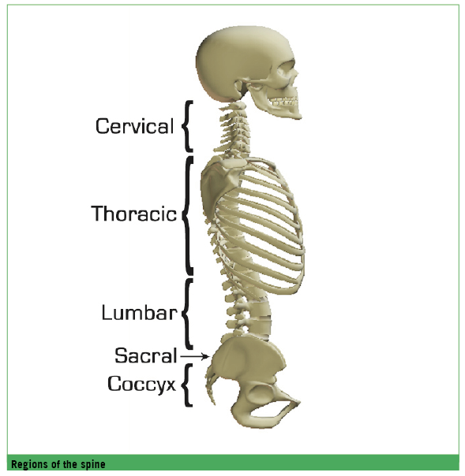

4.3 joints
4.3 关节

Joints are the place where two bones meet. All human bones, except for the hyoid bone in the neck, form a joint with another bone. Joints hold the bones together and allow the rigid skeleton to move.
关节是两块骨相连的地方。除了舌骨以外，人体所有的骨都经由关节与另一骨相连，关节连接骨，使坚硬的身体骨骼可以活动。

4.3.1 types of joints most relevant to skiing:
4.3.1 与滑雪密切相关的关节类型：

• Ball-and-socket joint – the most mobile of all joints. Consists of a bone with a slightly egg-shaped head that articulates with the cup-shaped cavity of another bone. Ball and socket joints have a wider range of motion than other joints, permitting movements in all planes, as well as rotational movement around a central axis. The hip and shoulder are ball and socket joints
球窝关节：所有关节里灵活性最高的关节。球窝关节由顶端略呈球形的一骨和另一骨上的窝状腔洞（关节窝）形成。球窝关节的灵活性最好，可以使得骨块在所有解剖面上运动，包括绕中心轴的旋转运动。臀部和肩部即是球窝关节处
• Gliding joints – the articulating surfaces are nearly flat or slightly curved. These joints allow sliding or back-and-forth motion and twisting movements. Most of the joints within the wrist and ankle, as well as those between adjacent vertebrae, are gliding joints
滑动关节（平面关节）：骨的连接面接近平面或者只有轻微曲面。两骨可以彼此滑动、前后移动和扭转。大部分的滑动关节位于腕部和踝部，此外椎骨之间也是滑动关节
• Hinge joint – the convex surface of one bone fits into the concave surface of another. Such a joint resembles the hinge of a door in that it permits movement in one plane only. The elbow is a hinge joint while the knee is a modified hinge joint
铰链关节：一骨的凸面嵌入另一骨的凹面，铰链关节只能朝一个方向运动，类似门的铰链。肘部即是铰链关节，膝部则是另一种形式的铰链关节

4.3.2 types of joint movements:
4.3.2 关节运动的类型

• Flexion – bending parts at a joint so that the angle between them decreases and the parts come closer together (bending the leg at the knee). Increasing angle with the frontal plane
屈曲：弯曲关节的组成部分，使得关节各部分的角度和距离减小（例如在膝盖处弯曲腿部），同时关节各部分与额状面的角度增加
• Extension – straightening parts at a joint so that the angle between them increases and the parts move farther apart (straightening the leg at the knee). Decreasing angle with the frontal plane
伸展：伸直关节的组成部分，使得关节各部分的角度和距离增大（例如在膝盖处伸展腿部），同时关节各部分与额状面的角度减小
• Abduction – moving a part away from the midline (lifting the leg away from the body to form an angle with the side of the body). Moving away from the sagittal plane
外展：将身体某部分从中心线往外移动（例如侧向抬腿，与身体侧面形成一定角度），从矢状面向外移动
• Adduction – moving a part toward the midline (returning the leg from being away from the body to align with the body). Moving toward the sagittal plane
内收：将身体某部分向中心线收回（例如从外向内收腿，最后与身体保持一致），从外向矢状面移动
• Rotation – moving a part around an axis of a bone (twisting the head from side to side, turning the whole leg from the hip joint). Medial or internal rotation involves movement toward the midline, whereas lateral or external rotation involves movement in the opposite direction (away from the midline)
旋转：围绕骨的轴线旋转一骨（例如向左右扭头、在髋关节处旋转整条腿）。内旋是向身体中线靠近，而外旋则是向中线的反方向旋转（远离中线）
• Circumduction – moving a limb in a circular manner, this requires a combination of flexion, extension, abduction and adduction. The ball and socket joints of the hip and the shoulder are two of only a few joints that are capable of circumduction
回旋：使四肢的一骨进行回旋运动，回旋综合了关节的屈曲、伸展、外旋和内收。人体只有少数几个能够做出回旋运动的关节，其中就包含臀部和肩部的球窝关节
4.3.3 the ankle joint
4.3.3 踝关节

This is an important joint in skiing because it joins the two bones of the lower leg (Tibia and Fibula) to the talus bone of the foot. It is a hinge joint which can move the foot down (plantarflexion), and up (dorsiflexion). When the lower leg is moved onto the boot tongue while skiing the ankle movement is dorsiflexion.
踝关节对滑雪很重要，它连接了小腿的胫骨、腓骨和足部的距骨。踝关节属于铰链关节，可以将足部往下伸展（跖屈）和向上折曲（背屈）。滑行时当小腿贴靠雪鞋鞋舌，踝关节的动作属于背屈。

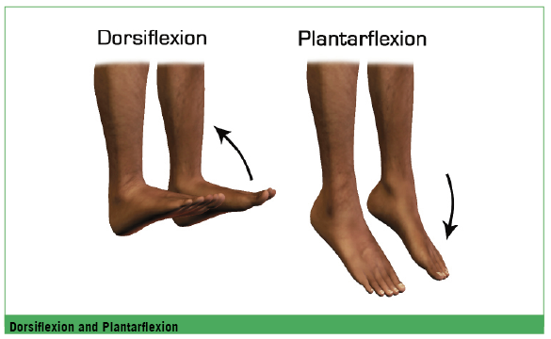

4.3.4 the foot
4.3.4 足部

The rest of the movements of the ankle and foot – twisting, tipping and side to side motion – occur in the complex system of bones in the foot and in the subtalar joint in combination with the muscles, tendons and ligaments in the ankle. This allows the movements of:
脚踝和足部的其他运动（扭转、垫脚、侧翻）则主要由足部复杂的骨骼系统和距下关节以及踝部的肌肉、肌腱和韧带完成，足部可以做出：
• Pronation – turning the foot so the sole faces outward or laterally (big toe side rotates down)
• 内旋：足底外翻、面向身体侧面（大趾侧下旋）
• Supination – turning the foot so the sole faces inward or medially (little toe
side rotates down)
• 外旋：足底内翻、面向身体中线（小趾侧下旋）
• Eversion – involves turning the sole of the foot outward. It combines lateral
rotation (toeing out) with pronation (rotating the little toes side of the
foot upward)
• 外翻：足底外转向身体侧面，它兼有横向旋转外张（大趾向外）也有内旋动作（小趾侧上旋）。
• Inversion – involves turning the sole inward combines medial rotation (toeing in) and supination (rotating the big toe side of the foot upward)
• 内翻：足底内转向身体正中，它兼有横向旋转内收（大趾向内）也有外旋动作（大趾侧上旋）。
Ankle movements are critical to good skiing but they are restricted by the ski boot. Fine edge control movements begin in the ankles and ankle tension is essential to make the skis hold. Active engagement of the ankle muscles is important for changing edges during turn initiation.
踝部运动对滑雪很关键，但它们的活动受到雪靴的限制。优秀的边刃控制始于踝部，踝部的紧张对雪板抓地非常重要。踝部肌肉的积极参与对入弯时的换刃尤为重要。

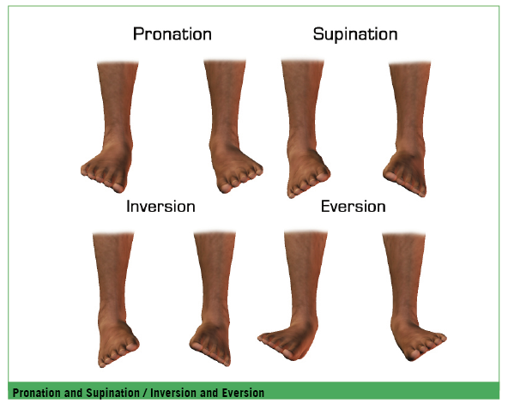

4.3.5 the knee joint
4.3.5 膝关节

As a hinge the knee joint has normal ranges of movement of flexion and extension, although a small amount of rotation and lateral movement is also possible.
膝关节是铰链关节，屈曲和伸展的幅度中等，但也能够做一些小幅度的旋转和横向运动。

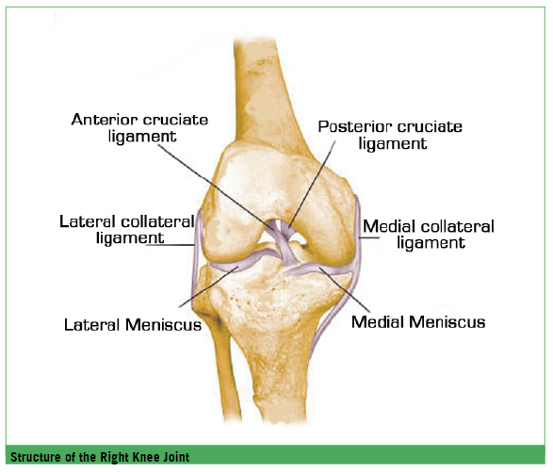

4.3.6 hip joint
4.3.6 髋关节

The hip joint has normal ranges of movement of flexion, extension, abduction, adduction, medial rotation and lateral rotation.
髋关节可以进行一般性屈曲、伸展、外展、内收、内旋和外旋。

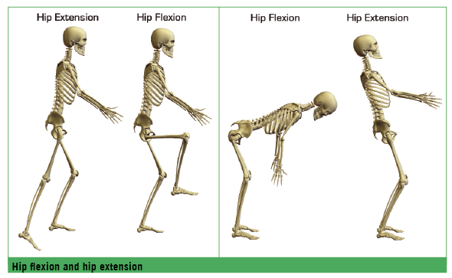

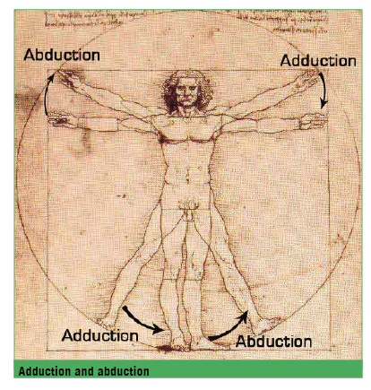

4.3.7 spinal column
4.3.7 脊椎

The vertebral column has normal ranges of movement of flexion, extension, lateral flexion and rotation.
脊椎可以进行一般性屈曲、伸展、横向折曲和旋转。
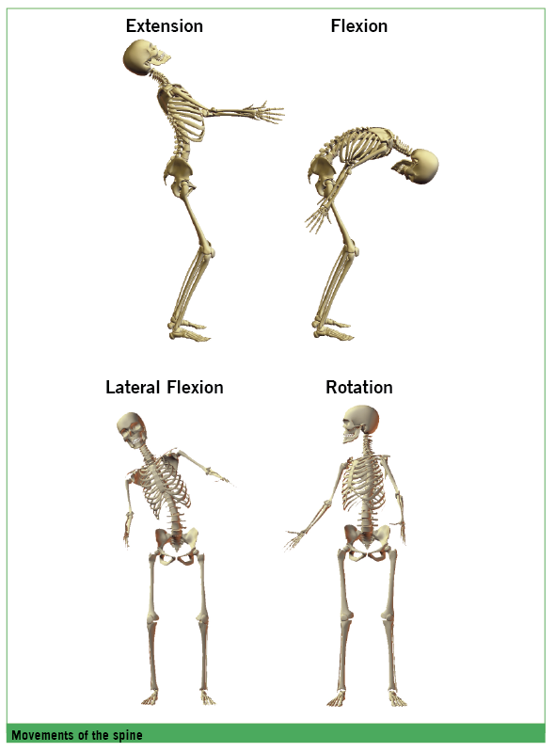

4.4 muscles
4.4 肌肉

The function of muscles is to produce force and cause motion. Muscles function in pairs to produce movement and when the first muscle contracts, the second muscle relaxes to allow movement. When the second muscle contracts the first muscle relaxes to allow movement in the opposite direction. The relationship between these muscle pairs is referred to as “antagonists.”
肌肉的作用是产生力和运动。肌肉运动通常成对作用产生运动，当一股肌肉收缩时，第二股肌肉就相应放松，如此便产生了运动。第二股肌肉收缩时，第一股肌肉就会放松，产生相反方向的运动。两股肌肉的关系被称为“对抗肌”。
Flexion and extension, abduction and adduction, rotation, supination and pronation and eversion and inversion are opposite movements that are controlled by muscle pairs.
屈曲和伸展、内收和外展、旋转、内旋和外旋、内翻和外翻，都是由对抗肌控制的相反运动。
concentric contraction
向心收缩
A concentric contraction is a type of muscle contraction in which the muscles shorten while generating force. Concentric contraction causes the muscle to shorten and change the angle of the joint.
向心收缩是指肌肉在产生力量时长度缩短。向心收缩导致肌肉缩短的同时，也改变了关节的角度。
eccentric contraction
离心收缩
During an eccentric contraction the muscle elongates while under tension due to an opposing force being greater than the force generated by the muscle. Rather than working to pull a joint in the direction of the muscle contraction, the muscle acts to decelerate the joint at the end of a movement, or otherwise control the repositioning of a load. This can occur involuntarily (when attempting to move a weight too heavy for the muscle to lift) or voluntarily (when the muscle is smoothing out a movement).
由于肌肉产生的力量小于对抗力量，因此肌肉在紧张收缩时实际被伸展了，离心收缩时关节并未向着肌肉收缩方向弯曲，而只是因为肌肉的离心收缩减缓了关节的运动，或者说离心收缩控制了承重的分布。这种肌肉收缩方式可以是被动的（例如超过承受范围的举重），也可以是主动的（例如有控制地放松一个身体运动）。
Eccentric contractions normally occur as a braking force in opposition to a concentric contraction to protect joints from damage. During virtually any routine movement, eccentric contractions assist in keeping motions smooth, but can also slow rapid movements, e.g. in skiing, smoothing out the vertical movements - flexion and extension.
离心收缩通常作为与向心收缩对抗的约束力量，用于保护关节不会因为活动过度而受损。几乎在所有日常运动中，离心收缩都会参与，以保障运动的流畅，它同时也可以减缓身体的高速运动，例如，在滑雪时稳定、有控制地进行屈曲和伸展的垂直运动。

isometric contraction
等长收缩
An isometric contraction of a muscle generates force without changing length, e.g. the muscles of the hand and forearm grip the ski pole, and after the pole has been gripped the joints of the hand do not move, but muscles generate sufficient force to prevent the pole from being dropped.
等长收缩是指肌肉在产生力量的时候不改变肌肉的长度，例如，使用手部和前臂肌肉抓握雪杖，握好之后手部关节不需要活动，但肌肉已经产生了足够的力量防止雪杖滑脱。
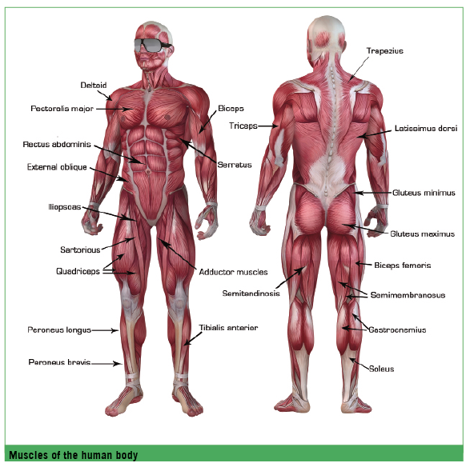

4.4.1 muscles of the lower legs
4.4.1 小腿肌群

• Ankle Inverters – the tibialis anterior and gastrocnemius muscles help to elevate the arch and therefore transfer more pressure to the outer border of the foot. Ankle inversion helps to maintain good medial and lateral alignment.
• 踝内翻肌：胫骨前肌和腓肠肌使足弓抬起，从而向足部外沿传导施压。踝内翻有助于保持身体内侧和外侧的一致性（横向连接）。
• Ankle Everters – the peroneus longus and brevis evert the ankle. These act to flatten the arch which places more pressure on the medial border of the foot. Ankle Everters help maintain good load distribution and medial and lateral alignment
• 踝外翻肌：腓骨长肌和短肌使踝部外翻，放平足弓向足部内沿施加更多压力。踝外翻肌有助于保持承重的有效分配，并保持身体内侧和外侧的一致性（横向连接）。
• Ankle Dorsiflexors – the tibialis anterior is responsible for dorsiflexion. The function of dorsiflexion (lifting the top of the foot toward the shin) helps maintain fore/aft balance and helps to balance the leg and foot to stabilise the leg on uneven ground. These muscles are most active during short turns and bump skiing
• 踝背屈肌：胫骨前肌负责背屈动作。足部背屈（朝胫骨/小腿抬升足背）有助于保持前后平衡，也有助于利用腿和足在雪面不平的地方保持平衡。踝背屈肌在做短弯和雪包滑行的时候最为活跃
• Ankle Plantarflexors – the gastrocnemius and soleus (calf) muscles act together to pull the foot down, away from the shin. These muscles are used to press the ball of the foot into the boot and are extended when the foot is in dorsiflexion
• 踝跖屈肌：腓肠肌和比目鱼肌（小腿）肌群协同作用将足部下沉、远离胫骨，跖屈肌群用来向足部跖球（脚掌下面近大趾根的球形部分）施压，足部背屈的时候跖屈肌群拉长
• The Gastrocnemius and Soleus Muscles – the action of the calf muscles also include flexing the leg at the knee joint and the development of tension. They are powerful muscles and vital in skiing. The soleus plays an important role in maintaining standing posture because if not for its constant pull, the body would fall forward
• 腓肠肌和比目鱼肌：小腿后侧肌群的活动包括于膝关节处屈曲腿部和形成张力。小腿后侧肌群强壮有力，对滑行至关重要。如果没有比目鱼肌的持续拉力，人体就会向前摔倒，因此它对于保持直立姿势非常关键
4.4.2 muscles of the knees and legs
4.4.2 膝部和腿部肌群

• Knee Extensors – the quadriceps femoris is a large muscle group consisting of four muscles on the front of the thigh which act together to extend or straighten the leg
• 膝伸肌：股四头肌是一组大肌群，包括大腿前侧的四块肌肉，四头肌合力作用于伸展腿部
• Knee Flexors – the hamstring is a group of three muscles that act together to bend the knee. The hamstrings also provide stability at the knee joint helping the anterior cruciate ligament to prevent forward movement of the tibia on the femur. The hamstrings oppose the quadriceps to flex the leg
• 膝屈肌：腘绳肌由三块肌肉组成，与伸展腿部的股四头肌相对应，腘绳肌群共同作用使膝盖弯曲。腘绳肌辅助前十字韧带（前交叉韧带）为膝盖提供稳定性，在股骨侧防止胫骨向前折曲

4.4.3 muscles of the pelvis and legs
4.4.3 骨盆和腿部肌群

• Hip Extensors – these enable movement of the thigh behind the torso. In skiing these muscles, while in active contraction, will lessen flexion in the legs
• gluteus maximus are the muscles surrounding the posterior of the pelvis. Strong “glutes” are important to resist the powerful forces of skiing
• hamstrings are the large muscles of the back of the thigh opposite the quadriceps
• 髋伸肌：髋伸肌使大腿得以向身后运动。在滑雪中如果该肌群紧张收缩，会减少腿部的弯曲
• 臀大肌包裹骨盆后部（臀部），强而有力的臀肌对对抗滑行时的力非常重要
• 腘绳肌与股四头肌相对应，是位于大腿后部的大肌群
• Hip Flexors – this group of muscles act to flex the femur towards the pelvis i.e. pull the knee upward. They are located at the front of the abdomen and leg and in skiing they are used in flexion movements.
• 髋屈肌：髋屈肌使得大腿向骨盆方向收缩，比如向上抬膝盖。髋屈肌位于腹部前部和腿部，在滑雪中主要用来做屈曲动作
• Hip Rotators – this group of muscles are found at the posterior of the pelvis and into the upper femur. The hip medial and lateral rotators are very important in balancing and supporting the other motions of the hip. They help stabilise the femur in the hip socket. These muscles rotate the femur at the hip joint. If the knees are pointed towards each other while standing the femurs are rotated medially (inwards). If the knees are turned away from each other the femurs are rotated laterally (outwards)
• 髋回旋肌：回旋肌群位于骨盆后部（臀侧）和股骨上端。髋部的内外旋转对于支撑和平衡臀部其他活动非常重要。回旋肌群有助于将股骨稳定于髋部球窝关节内。它可以让股骨在髋关节处回旋活动。如果站立时膝盖相对，则股骨向内旋，如果膝盖向外分离，则股骨向外旋
• Hip Abductors – these muscles enable the leg to move away from the midline of the body. The primary hip abductor is the gluteus medius. In combination with the hip adductors (inner thigh) these muscles are important in skiing for shifting weight to bring the centre of gravity into alignment with the supporting skeletal structure
• 髋外展肌：髋外展肌群可以使腿部远离身体中线向外展动，外展肌群主要的肌肉是臀中肌。在滑雪中，髋外展肌群和内收肌群（大腿内侧）共同作用可以使人体实现重心转移，并使重心与支撑人体的骨骼结构在空间上保持一致，因而这两大肌群对滑雪也很重要
• Hip Adductors – these are the inner thigh muscles and enable the legs to move toward the midline of the body. In skiing they are used to stabilise the skis. Rotation of the legs is a combination of rotation and abduction
or abduction
• 髋内收肌：位于大腿内侧，可以使腿向人体中线移动，滑雪时用于稳定雪板。腿部的旋转是旋转和外展/内收的共同作用

4.4.4 muscles of the torso and core
4.4.4 躯干和核心肌群

• The Spinal Extensors are attached to the back of the spine and enable standing up and lifting objects. The extensors counterbalance the action of the abdominals
• 脊柱伸展肌附着于脊柱后侧，用于直立身体和抬举物体。脊柱伸展肌群与腹部肌群抗衡
• The Spinal Flexors are in the front of the spine and include the abdominal muscles. These muscles when contracting concentrically enable flexion or forward bend. They are important in lifting and controlling the arch in the lower back
• 脊柱收缩肌位于脊柱前侧，包含腹部肌群，肌群向心收缩可以实现脊柱收缩或向前弯曲。它对于拉伸和控制下背弓部很重要
These muscles stabilise the spine and therefore the whole torso. In skiing they are responsible for enabling skiers to maintain fore/aft and lateral balance and providing a stable upper body to facilitate rotation of the legs.
上述肌群给予脊柱稳定性，因而也使得整个躯干稳定。在滑雪中，它们使人体保持前后和横向平衡，同时稳定上身也有助于腿部的旋转。

4.4.5 abdominal muscles - the core
4.4.5 腹部肌群——核心

The abdominal muscles are a group of six muscles that extend from various places on the ribs to various places on the pelvis. These muscles provide postural support as well as enabling movement in the torso. They are often referred to as the core and also assist in the breathing process.
腹部肌群由六块肌肉组成，分别从肋骨的不同地方延伸至骨盆的不同位置，腹部肌群为人体提供了姿势上的支撑，也使得躯干可以活动。腹部肌群常被称为核心，它的作用也包括协助呼吸活动。
The more structurally deeper and closer to the spine the particular abdominal muscle is, the more effect it has over body posture. The six abdominal muscles all affect body posture.
腹部肌群中越深层、越靠近脊柱的肌肉，对身体姿势的影响越大。6块腹肌对身体姿势都有影响。
From deep to superficial the abdominal muscles are:
腹部肌肉依照深层到表层的顺序依次为：
• Transverse Abdominal – the deepest abdominal muscle and has the most effect on body posture. The transverse abdominal runs from the sides of the torso (lateral) to the front of the torso (anterior)
• 腹横肌：位于腹部肌群的最内层，对身体姿势的影响最大。腹横肌从躯干侧面横贯至躯干前方
• Internal Obliques (x2) and External Obliques (x2) – these two pairs of abdominal muscles are on each side of the torso. The external obliques are more superficial. Both sets of obliques affect body posture, but slightly less because of their more superficial position. They are involved in rotation and lateral flexion movements of the spine
• 腹内斜肌（x2）和腹外斜肌（x2）：两对腹肌分布于躯干两侧，其中腹外斜肌位置较浅。两对斜肌由于较腹横肌浅，对身体姿态的影响也略低。斜肌参与脊椎的旋转和横向弯曲
• Rectus Abdominis – is the most superficial of the abdominal muscles. It is a long flat muscle, which extends along the length of the front of the abdomen and together with the external obliques affects body posture, but not as much as the deeper abdominal muscles. This muscle is responsible for flexing the lumbar spine and as such maintaining accurate alignment of the pelvis
• 腹直肌：是腹部肌群最靠外侧的肌肉，形状呈带状，沿腹前臂分布，与腹外斜肌协同作用对身体姿态造成影响，但影响程度不如深层肌肉。使用腹直肌弯曲/收缩腰椎可以使之保持与骨盆的一致性

4.4.6 muscles of the upper torso
4.4.6 躯干上部肌肉

• Upper Back Muscles
• trapezius – a triangular shaped muscle that runs from the centre of the back up to the neck and across the shoulder blades. This helps to maintain good posture for the upper spine, neck and head
• rhomboids – these muscles run from the base of the neck to the shoulder blade and help to hold the shoulders back and maintain good posture
• 上背部肌群
• 斜方肌：斜方肌是一块三角形的肌肉，从背部中间穿过两块肩胛骨向上延伸到颈部。斜方肌有助于人体保持上部脊椎、颈部和头部的正确姿势
• 菱形肌：从颈部底部延伸至肩胛骨，使背部维持向后的牵拉/挺胸，保持良好体态
• Shoulder Muscles – in skiing the shoulder muscles are important for good posture and stability of the torso and arms and consist of:
• deltoid muscles which wrap right around the top of the shoulders giving the shoulders versatility and a greater range of movement
• rotator cuff muscles, located beneath the shoulder, help to hold the arms in place
• 肩部肌群对于在滑雪时维持良好姿势、保持躯干和手臂的稳定很重要，它包括：
• 三角肌包绕肩部顶端，赋予肩部灵活性和更大的运动范围
• 肩袖肌群位于肩部下方，用于保持手臂的位置

• Chest Muscles
• pectorals – these run across the surface of the chest and in skiing help to stabilise the upper body including the arms
• 胸肌
• 胸肌：分布于胸部的整个表面，在滑雪时对保持上半身包括手臂的稳定有帮助
• Arm Muscles
• biceps – located at the front of the upper arm and used to flex the arm at the elbow. In skiing used together with the forearm muscles and wrist in the pole swing
• triceps – located at the back of the upper arms, these muscles oppose the biceps and come into play to extend the arm
• 手臂肌群
• 二头肌：位于上臂的前侧，可以使前臂在肘关节处屈曲。在滑雪中主要与前臂肌群和腕部一同使用，完成摆杖活动
• 三头肌：位于上臂后侧，三头肌与二头肌相对，用于伸直和伸展手臂

4.5 connectors and cushions
4.5 连接和缓冲

In addition to the muscles there are other soft tissues that help connect the body together:
• tendons are the tough fibrous cords that attach muscle to bone
• ligaments are the tough fibrous tissues that connect bones to other bones to form a joint
• cartilage forms the slippery surface of bone ends in joints
除了肌肉，人体还有许多其他软组织参与身体的连接：
• 肌腱是连接肌肉骨骼的纤维性坚韧索状组织
• 韧带是纤维样的坚韧结缔组织，它在骨之间连结，形成关节
• 软骨形成骨端关节的光滑表面

notes
附注

photo captions:
图片内容:
The Anatomical Planes of Movement
人体运动的解剖平面
The Human Skeleton
人体骨骼
Regions of the spine
脊柱的分区
Dorsiflexion and Plantarflexion
背屈和跖屈
Pronation and Supination / Inversion and Eversion
内旋和外旋/内翻和外翻
Structure of the Right Knee Joint
右膝关节结构
Hip flexion and hip extension
臀部的屈曲和伸展
Adduction and abduction
内收和外展
Movements of the spine
脊柱的运动
Muscles of the human body
人体肌肉

