freeski – pipe and park
自由滑雪——U型场地和公园

The sport of freeskiing encompasses the half pipe, terrain parks and any natural features that can be found in the mountain playground. It is continually evolving, with skiers exploring their boundaries, and developing new tricks.
自由滑雪包括U型场地、地形公园和场地上的其他自然道具。随着滑雪者不断超越个人极限、掌握新的花样技巧，自由滑雪的形式和内容也会逐渐丰富。

The popularity of freeskiing has seen increased investment in the creation of half pipes and terrain parks by ski areas which in turn has led to an increase in demand for freeski lessons.
伴随着自由滑雪的兴起，滑雪场地纷纷兴建U型池和地形公园，自由滑雪课程的需求也日益旺盛。
This chapter covers the areas of
• safety • park riding
• half pipe • basic flatland manoeuvres
本章内容涵盖：
• 安全 • 公园滑雪
• U型池 • 基础平花

8.1 general pipe and park safety
8.1 U型场地和公园滑雪的安全问题

As in all ski lessons safety is the first consideration when entering the pipe and park. This section provides a guideline for a successful freeski session under the supervision of an instructor/coach. There are several simple rules that outline the behaviour of people in the group, the behaviour of the instructor/coach and the common etiquette of park and pipe users.
跟其他滑雪教学一样，在进入公园滑雪时，安全仍是第一位的。本节为教练员提供了自由滑雪相关指导原则，包括集体活动规范、教练员行为准则和公园滑雪行为准则。

• park area/zone – these areas are generally roped off and are the domain of skiers and riders using the park. No one else should be in here unless they are riding the park or performing maintenance/safety tasks
• 公园区域：本区域通常与普通滑行区域有分隔，专属公园滑手使用。除公园滑行者和养护、巡逻人员之外，无关人员不应进入
• flow of the riders – the path the riders take from feature to feature is known as flow. Most parks have more than one line which allows more than one rider dropping at the same time. The best place to enter the park or drop-in is always at the top/start. Should a rider fall it is important to move out of the landing, and before continuing find a suitable gap in the traffic
• 滑行“流线”：连接不同道具形成的雪道路径叫做“流线”（Flow）。大部分公园都有不止一条流线，方便多人同时滑行。进入公园的最佳位置永远是流线顶端的开始处。如果在滑行时摔倒，应立即离开落点位置，再继续时需要找准人流空隙进入雪道
• self assessment – much like ski runs most of the parks have a difficulty rating. However there is no global measure or rule on how to rate a park. Therefore it is very important for instructors to know the level and ability of the skiers and for individual skiers to know their own level before entering the park. The message is to always Pre-ride, Re-ride and Free-ride the park:
• 水平评估：跟雪道一样，公园也有难度评级，但并没有一个国际统一的评定标准。因此在进入公园之前，教练很有必要评估学生的能力水平，而一般公园滑手要对自身水平进行评估。这个过程应遵循预滑、重滑、自由滑的顺序：
• Pre-ride – riding through the park and assessing the features and speed needed
• 预滑——在公园流线上贴地滑行一次，了解道具情况，预估需要的速度
• Re-ride – straight air or rail slide with no spins
• 重滑——再次滑行，只做直线跳跃或杆式道具直线滑行，不做转体
• Free-ride – start with simple tricks and build up difficulty through repetition on the feature
• 自由滑——以简单的花样技巧开始，通过在道具上不断练习，逐渐增加动作难度

• group handling – riding the park with a group of skiers requires more attention than riding alone. Respect the park zone boundary, don’t disrupt the flow of traffic and make sure everyone in the group is able to ride the park. If some people are uncomfortable with any features in the park, it is okay to skip them providing they are not disrupting park flow. In some park zones there are areas sufficiently large enough to provide space for a group to stop. These areas must also provide a safe view of features above and below
• 集体管理：以群体为单位进行公园滑行，比独自滑行更需要管理。原则是不越过公园界、不干扰滑行人流并确认每人都有能力做公园滑行。如果有成员对某个道具没有把握，在不干扰公园流线的前提下，完全可以越过这个动作点。有的公园区域有足够大的场地供群体停留，停留点的选择同时应满足安全地观察上下方道具的要求。

• sessioning one feature – in some situations when the park zone is not busy it is possible to use just one feature, usually a box or rail. This is common when working on specific tricks rather than completing a whole lap through the park
• 单一道具练习：公园如果人不多，就可以在同一个道具上反复练习，通常是Box或Rail（箱式道具或杆式道具）。如果要掌握某个特定花样技巧，与其完成整个公园流线，单独练习会比较常见。

• appropriate safety equipment such as helmets are recommended at all times when in the pipe and park
• 恰当的安全护具：例如头盔，公园滑行建议随时佩戴头盔

8.2 park and pipe riding
8.2 公园和U型场地滑行
The second goal of the freeski lesson after safety is to introduce the skiers to pipe and park riding and provide them with the satisfaction of doing simple tricks in the pipe, off the jumps and on the rails and boxes. This requires a full assessment of the students. Are they physically able to do what they are being asked to do? Do they have all the skills required?
安全有保障后，自由滑行的第二课就是介绍公园和U型场地滑行了，让学生在U型池、跳台、Rail（杆式道具）和Box（箱式道具）上做一些简单花样，可以带来成就感。这也要求全面评估学生水平。他们的生理情况能不能完成规定动作？需要的滑行技术掌握了吗？

Aside from the general fitness requirements which include – balance, co-ordination, proprioception, explosive strength, power and flexibility – there are skill groups that need to be developed that are specific to the sport of freeskiing.
除了一般性的身体要求（平衡能力、协调能力、本体感受能力、爆发力、力量和灵活），还有一些技能是自由滑雪必备的。

the skills are:
它们是：
• take off skills
• approach speed
• timing
• pressure control
• setting up for take off/trick
• 起跳技术
• 助滑速度
• 时机
• 压力控制
• 起跳/花样技巧的预备
• air time
• controlling body position
• 滞空时间
• 控制身体姿态
• landing
• spotting the landing
• preparation for landing
• absorbing the impact
• 着陆
• 确定落点
• 着陆准备
• 吸收冲击

Skiers will come into the session with a set of skills from other sports that will help them as part of their general fitness. The sport specific skills, however, can be gained only through training. This is where the role of coaches/instructors becomes important because the skills need to be introduced in a safe way. Every trick and move in pipe and park riding comprises different combinations of the above skills which are required to perform tricks safely.
公园滑手在其他运动中获得的运动技能可以作为一般性体能技术的一部分，对公园滑行有帮助。但公园滑行特有的技术则需要经由训练获得。指导员/教练的角色非常重要，指导员/教练要以一种安全的方式展开技术教学。公园和U型场地的每一种花样技巧和动作都需要用到上述技术的不同组合，才能确保安全。

8.3 jumping
8.3 跳台跳跃

Getting air on skis is one of the most exhilarating things to do. The improved development of manmade features allows more air time, less compression on the takeoff and less impact on the landing. This enables the top riders to perform harder and more complicated tricks. It also enables less skilled riders to get a lot of air time.
带板飞行是最激动人心的了。人工跳台不断发展，已经可以让滑手获得更多滞空时间，起跳时雪面压力更少，着陆时冲击力减小。顶级滑手可以做出更高难度、更复杂的花样技巧。技术水平略低一些的滑手也能获得更多的滞空时间。

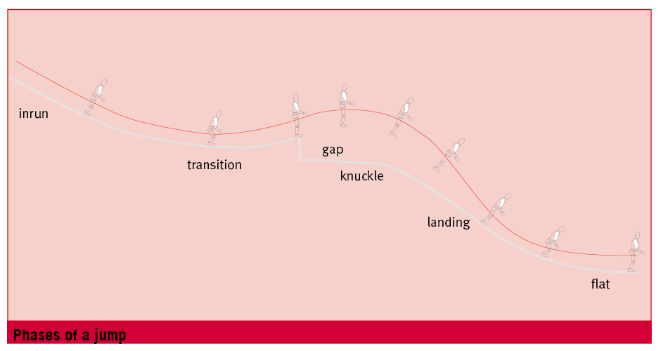

8.3.1 take off skills
8.3.1 起跳技术

Approach Speed
助滑速度
Approach speed is crucial for the safe and successful completion of jumps and to ensure reaching the ideal sweet spot on the landing. Getting the right speed for the jump can be done by observing the other riders, marking where they start and noticing how many turns/speed checks they do. Conditions can change rapidly - the temperature can drop, the wind can change, a thin layer of snow can fall or be cleared by the crew, the angle of the sun can change – and any one of these can affect the approach speed.
助滑速度对安全完成跳跃非常关键，同时它也是滑手落在最佳落地点的保障。通过观察其他滑手的起滑点和转弯/速度调整（speed check）的次数，可以得到起跳助滑的合理速度。但滑行条件的变化很快，气温下降、风向改变、雪道上下了一层薄雪或者原本的薄雪被清掉了、太阳的位置变化，这些因素任一的改变，都会影响助滑速度。
（speed check，各类板式运动的速度管理常用方法，在滑雪中通常是将雪板斜推/横推利用雪面反作用力降低和调整滑行速度——译者注）

Timing and Pressure Control
时机和压力控制
Resisting the compression (pressure control) and the timing of the takeoff are key elements. The skier should copy the shape of the jump and be as smooth as possible. Excessive extension or pop will not significantly lengthen the air time on manmade jumps; however it may be necessary on some natural features. At takeoff the skier is focused on setting the right body position and stability for any tricks. The compression can force the skier to flex which leads to a flatter trajectory and possibly shorter air time while excessive extension usually leads to fore/aft instability and other balance problems. It also creates unwanted movement patterns for halfpipe riding.
对抗雪面的反作用力（压力管理）和起跳时机都是需要考虑的关键要素。滑手路径应顺应跳台的形状，并尽量流畅。在人工跳台上，过度引身或主动跳起并不会显著增加滞空时间，但在某些自然道具上却可以奏效。起跳时应重点调整到正确的身体姿势，确保花样技巧的稳定性。雪面压力可能会迫使滑手屈身，导致跳跃弧线趋平，滞空时间也可能缩短，而过度引身则通常导致前后不平衡和其他平衡问题。在U型场地滑行时，同样的问题也会导致一些不应出现的运动表现。

Setting up for Takeoff/Trick
Prior planning is essential for a successful jump. The skier should know what he/she is going to do prior to the run-in. At takeoff the skier should be perpendicular to the snow in an athletic stance, skis should be flat to the snow and takeoff is from both legs. Rotational manoeuvres are started while the skis are still on the snow not once the skier is in the air.
起跳/花样技巧的预备
跳台跳跃的前期规划非常重要。在进入助滑道之前，滑手就要知道接下来的操作内容。起跳时，滑手保持滑行姿势并与雪面垂直，雪板与雪面贴合，双腿起跳。旋转驱动应该在雪板未离开地面时就已经开始，而不是起跳之后才做。

8.3.2 air time
8.3.2 滞空时间

Air time provides the space to perform tricks. The combinations of spins and flips in various axes combined with grabs provides unlimited options of trickery.
滞空为施展花样技巧提供了空间。绕不同轴线进行转体和空翻、结合抓板动作，可以构成无限可能。

The main groups of tricks are:
主要的花样技巧包括：
• straight airs
• 直线跳跃
• grabs
• 抓板
• upright rotations - simple rotations around the vertical axis
• 直体转体——绕垂直轴进行简单旋转
• switch takeoffs
• 倒滑起跳
• corks – back flip based trick with spins around a non horizontal changing axis
• corks——后空翻加不规则斜向转体
• bios – front flip based tricks with spins
• bios——前空翻加转体

The standard pathway for learning air time goes from easiest to hardest – straight airs, spins up to 720 including switch, flips, and corks/bios but there is no defined progression from trick to trick. Different skiers prefer different directions of spins and different axes of rotation. Each skier has a skill set that is unique and will pursue personal strengths rather than weaknesses.
空中技巧的学习也是由简到难，按照难易度顺序分别是：直线跳跃、倒滑起跳加空中转体720、空翻、Corks和Bios。但技巧与技巧之间并没有一个标准的进阶过程。不同滑手对转体和空翻的方向偏好不同。每个滑手的技术构成都不一样，应扬长避短。

Controlling body position
控制身体姿势
All moves in the air need to be balanced. The action/reaction rule requires that every movement made while in the air requires a movement of the same strength in the opposite direction to remain in balance, e.g. lifting the knees while in the air will cause the skier to begin to rotate backwards, but if the skier also moves the upper body forward he/she will stay balanced.
空中动作必须是平衡的。作用力与反作用力原则要求空中的每个身体运动都有同等力度的反向运动，以保持身体平衡，例如，在空中抬高膝部会使人体向后旋转，但如果同时将上身前倾，就会保持稳定平衡。

8.3.3 landing
8.3.3 着陆

The last phase of the jump–landing is as important as the others. Safe completion of the jump depends on these skills
跳台跳跃最后一步是着陆，落地过程跟其他步骤一样重要。安全完成跳跃动作主要靠以下技巧：
• Early spotting of the landing – skier should focus their eyes on where they are going to land as early as possible. In a straight air this will happen at the apex of the jump, in spins this will happen later
• 落点早确定：滑手应该尽早看向落地位置。直线跳跃时在跳跃顶点确定落点，有转体动作时落点的确定会
稍晚
• Preparation for landing – the skier should land perpendicular to the snow so adjustments will have to be made in the air as the landing will not be at the same angle as the take off. Skis should be flat to the snow and pointed in the direction of travel
• 预备着陆：着陆时身体应该与雪面垂直，由于落地角度与起跳角度不会一致，因此姿势调整应该在空中进行。落地时雪板与雪面贴合，并指向行进方向
• Absorbing the impact – the skier should land in an athletic stance with muscular tension and be able to absorb the impact of landing through flexion of the ankles, knees and hips
• 吸收冲击：着陆时应以滑行姿势落地，保持肌肉紧张，通过踝、膝、髋屈曲吸收落地冲击

8.3.4 guideline progressions
8.3.4 教学进程纲要

introduction to straight air
直线跳跃
Terrain
• a small table top jump (no gap jumps)
地形
• 小型梯形台（不可以是有沟的跳台）
Progressional Steps
教学步骤
• introduce the phases of the jump
• 介绍跳台结构分区和跳跃的不同阶段
• pre ride – assess the feature
• 预滑——进行跳台评估和熟悉
• ski over the jump without taking any air, focusing on maintaining an athletic position and remaining perpendicular to the snow during the take off/airtime and landing phases of the jump
• 不起跳，贴地滑过跳台，在起跳、滞空和着陆的相应阶段，练习身体姿态、保持身体垂直于雪面
• increase the run in speed so that air is taken, maintain the focus of being balanced and perpendicular to the snow through all phases of the jump
• 增加助滑速度起跳，保持全程身体平衡、并垂直于雪面

360
转体360
Terrain
• natural terrain features and spines
地形
• 自然地形道具和脊状隆起

Progressional Steps
教学步骤
• with skis off attempt 360 spins using the eyes and upper body to lead the rotation. Practice in both directions
• 脱板，用眼睛和上身引导身体360旋转，顺时针和逆时针都要练习
• with skis on perform a J turn until skis are pointed directly up the hill then jump and spin until the skis are pointed down the hill
• 穿板做J字转弯，当雪板直冲山上时，起跳、转体，直到雪板冲山下
• using a side hill, ski up the hill and jump and rotate 270 and ski out focusing on maintaining an athletic stance throughout. Practice in both directions. The rotation is in the direction back up the hill (also known as an alley oop) and the timing of the rotation should begin as forward momentum begins to stall
• 利用山侧斜坡，向坡上滑行，然后跳起、转体270后滑出，全程保持滑行姿势。顺时针和逆时针方向都要练习。旋转方向是向山上旋转（又称空中接力alley oop），旋转的时机是向前的动能开始减弱时
• using terrain that allows a takeoff across the fall line with a landing down the fall line, perform the same manoeuvre as above. This is the first attempt with the takeoff and landing at different angles and the skier will need to make adjustments while in the air to land in a balanced position (refer to straight air)
• 找一个合适地形，能够在横穿滚落线时起跳，然后冲滚落线下方落地，重复上述转体270练习。这是第一次以不同角度起跳和落地，滑手应该在空中调整、以一个稳定平衡的姿态落地（参见直线跳跃）
• use a small knoll and perform a 360 both taking off and landing in the fall line. This requires an increased range of rotation. Through the last half of the rotation the skier should be spotting the landing which will aid in maintaining a balanced position through the air
• 找一个小雪堆练习转体360，起跳和落地都在滚落线上，这个动作要求旋转幅度加大。在转体后半段，要全程盯住落点，有助于在空中保持平衡姿势

8.4 rails, boxes, walls
8.4 杆式道具、箱式道具和墙体
This group of features requires skis sliding on different types of surfaces such as plastic, metal and wood. The features come in many different shapes and sizes and some can be skied straight on to while others require a jump to get on to. As with jumping the approach to the feature is an important consideration. Correct alignment with the rail on the run-in will set the skier up for success.
这一类道具要求雪板在不同质地的表面上滑行，包括塑料、金属和木材。这类道具形状大小各异，有的可以直接滑上去（直通式），有的需要跳上去。跟跳台跳跃一样，道具滑行的助滑也很重要。在助滑进近的时候保持与道具路线的一致，有利于滑手顺利完成滑行。

the core skills for riding boxes, rails and walls are:
杆式道具（rail）、箱式道具（box）和墙体滑行的核心技术包括：
• the ability to jump on to the box
• 跳上Box
• jump into the box with minimal impact on the box
• 以最小的撞击力跳上Box
• jumping only the height required and landing at the beginning of the box
• 以恰当的高度跳起、在Box的起始处落下

• the slide
• 道具滑行
• slightly wider and lower stance than normal
• 滑行姿势比平时更低、张得更开
• centre of gravity above the base of support
• 重心处于支撑面上方
• body aligned square with the feature (no rotational separation)
• 身体与道具方向保持一致（没有旋转分离）
• skis flat (no edging)
• 用板底滑行（不立刃）
• eyes focused on the end of the feature
• 目视道具末段
• the landing
• 落地
• depending on the feature the skier may be able to slide off or may have to jump off
• 根据道具情况不同，落地情况各异，可能直接滑出、也可能需要跳跃落地
• skis need to be aligned in the direction of travel when exiting the feature
• 离开道具时雪板要与行进方向保持一致
• spot the landing
• 看向落地点
• absorb the impact
• 吸收冲击

These features vary in difficulty, boxes are generally easier due to the fact that they are wider under foot and therefore allow more margin for error. Some can be skied over in a straight run as an introduction to the feature.
不同道具难度不同，Box滑行面更宽，容错度更高，相对也更容易。有些Box可以做直线滑行，教练可借此进行教学引入。

8.4.1 guideline progression
8.4.1 教学进程纲要

sliding a box sideways
Box横滑
Terrain
地形
• a beginner level flat box with a ski on entry
• 初级水平的直通式宽型Box
Progressional Steps
教学步骤
• pre ride – assess the feature
• 预滑——评估和熟悉道具
• ski over the feature in a straight run (also known as a 50-50) at an appropriate speed, maintaining an athletic stance throughout. Balance will be challenged due to changes in friction in different sliding surfaces
• 在道具上以适宜的速度直线滑行（也称50-50），全程保持滑行姿势。不同滑行表面摩擦阻力不同，因此要调整身体保持平衡
• have the skier stand on the box sideways and shuffle along it maintaining an athletic position and keeping the body square to the box
• 让学生横向站立于Box上，两脚平移沿Box方向挪动，保持滑行姿势，保持身体与Box的方向一致
• step one ski on to the box and push off with the other ski and slide the box
• 一只板放在Box上，另一只脚蹬板沿Box滑行
• ski on to the box 50-50 and then jump 90 degrees and slide the box
• 以50-50滑上Box，做90度跳转沿Box滑行
• ski up the run-in with a wider stance and the box lined up between the skis, jump and land on the box sideways keeping weight even on both feet and maintaining the wide stance. Jump off at the end of the box and turn the skis into the direction of travel
• 以较宽的滑行姿势滑上助滑道，雪板中间与Box方向一致，跳转、横向落地于Box上，保持较宽的滑行姿势、重量平均分布于双脚，开始横向滑行。在Box末端跳下，将雪板拧转至行进方向

8.5 half pipe
8.5 U型池

Half pipes are one of the most challenging terrain features and can be man-made or natural. A good half pipe has a smooth transition with virtually no flat bottom and walls that become vertical. Riding the half pipe combines the elements of good skiing (pressure and edge control) with jumping skills (upper body rotation and balance).
U型池是最有难度的人工或天然道具之一。一个好的U型池应该是过渡区域流畅平整，底部没有平面，两侧没有垂直壁面。U型池滑行综合了流畅滑行技术（压力和边刃控制）和跳跃技术（上身的旋转和平衡）。

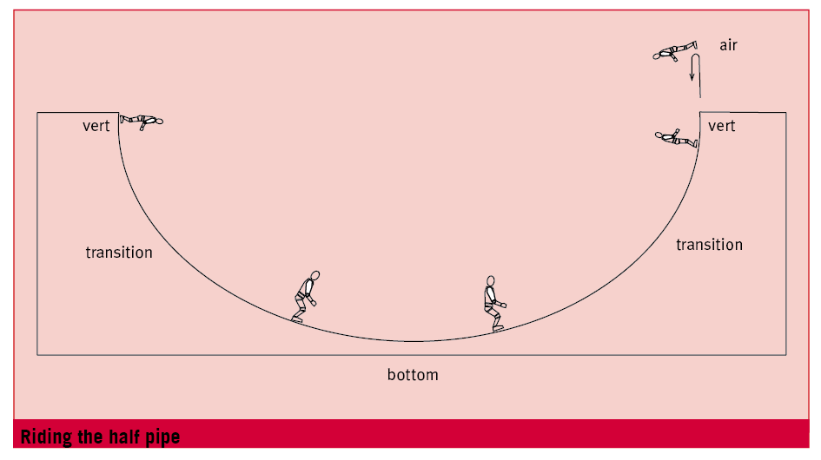

There are five technical areas to riding the half pipe:
U型池滑行划分为5个技术分区：

1. bottom
1. 底部
The nearly flat part between the walls. The focus through this part of the pipe is on hitting the wall at the appropriate place and pointing the skis down or across the fall line for speed adjustment. Skis should be edged for control and speed adjustment is made by adjusting the line, not by skidding.
两壁之间接近平地的部分。滑行要点是寻找合适的上壁点，以及利用雪板指向滚落线或斜穿滚落线进行速度调整。雪板应该立刃控制，速度调整通过调整线路完成，而不是利用搓雪。

2. transition (tranny)
2. 过渡部分（简称tranny）
This is the area between the bottom and the top of the wall. The focus here is to remain perpendicular to the wall in a good athletic stance. Due to the rounded surface there is an increase in forces acting upon the skier which is felt as pressure from the wall against the skis and legs. Muscular effort is required to maintain a good stance.
这一部分是池底部和两壁顶部之间的区域，滑行要点是以良好的滑行姿势保持与墙面垂直。由于过渡部分为弧面，施加于滑手的作用力会增加，人体可以感到墙面对雪板和腿部的压力越来越大。要保持良好的滑行姿态需要肌肉发力。

3. vertical (vert)
3. 垂直边缘（简称vert）
The top part of the wall. Remaining perpendicular to the wall will provide the skier with the ability to make any necessary fore/aft adjustments to adjust to the shape and condition of the pipe, and prepare for a balanced take-off. Eyes should be focused above the lip of the half pipe.
两壁的顶端部分。滑行要点是人体与墙面保持垂直，以便进行必要的前后调整，以适应U型池的形状和条件，并为一个稳定的起跳腾空做准备。眼光应望向池壁边缘上方。

4. air/trajectory
4. 空中路线
The speed carried through the transition and vertical section dictates the amount of air time. While in the air the skier should remain or return to a position that is perpendicular to the vert prior to landing.
在过渡部分和垂直边缘获得的速度直接决定了滞空时间的长短。在着陆之前，滑手应该在空中保持或回归垂直于边缘部分的身体姿势。

5. landing
5. 着陆
The skis should touch down as high up the wall as possible, and parallel to the required direction of travel, allowing the skier time to rebalance and prepare for the change in forces through the transition and gain momentum for the next hit.
雪板落点应该尽量位于壁面高处，然后平行指向行进方向，留出时间回归平衡，为过渡区域力的改变做准备，并为下一次上壁获得动量。

8.5.1 guideline progression
8.5.1 教学进程纲要

Introduction to half pipe riding
U型池滑行
• parallel turns through the pipe with turns on the walls with a focus on maintaining an athletic position and remaining perpendicular to the surface of the snow
• 以上壁转弯的方式，平行转弯滑行穿过U型池，要点是保持滑行姿势和与雪面垂直
• slowly increase the number of turns by tightening the turn radius
• 逐渐减小转弯半径，增加转弯次数
• introduce a hop turn on the wall using upper body rotation
• 通过上身旋转在侧壁上做出跳转（hop turn）动作
• the timing off the hop turn should happen as forward momentum begins to stall
• 跳转时机是向前的动量开始减弱时
• gradually aim to ski higher up the wall
• 逐渐往侧壁更高处练习

8.6 basic flatland freeski anoeuvres
8.6自由滑雪基础平花

8.6.1 switch skiing
8.6.1 倒滑
Skiing backwards requires the same fundamental skills as skiing forwards. Skiers should maintain an athletic stance (a focus on feeling boot contact on the calves rather than the shins can help with this). Safety is an important aspect of riding switch so skiers should be continually looking over their shoulder to see where they are going.
倒滑用到的运动技巧与正滑没有区别。保持滑行姿势（感觉小腿后靠而不是前靠，会有一定帮助）。倒滑一定要注意安全，需要不时回头查看行进方向。

8.6.2 ollie
8.6.2 ollie
An Ollie is a jump that begins on the tail of the skis and utilises the spring gained from bending the tail of the skis to gain height. To perform an Ollie flex and pressure the tails of the skis, then from here jump and project the centre of gravity forward to land in an athletic stance.
Ollie是以板尾起跳，通过弯曲板尾形成弹力获得一定高度。跳Ollie时屈身向板尾施压，然后从板尾起跳，将重心往前送，以滑行姿势落地。

8.6.3 jump 180
8.6.3 转体180

A jump and spin that takes a skier from skiing forward to switch or from switch to forwards. This can be practiced while standing still with skis on or off.
跳起旋转，由正滑变为倒滑或相反。可以在平地站定时，穿板或脱板练习。

notes
附注

Photo captions:
图片内容

Photo credit Chris O’Connell Armada Skis
图片由Chris O’Connell Armada Skis制作
Phases of a jump
跳台结构
50-50 on a box
Box上的50-50
Riding the half pipe
U型池滑行

